Norwegian Refugee Council (NRC)
Construction of water supply system
REHABILITATION, UPGRADING, DISINFECTING & CLEANING OF BOREWELLS
PR No.8200705, 8200706 & 8200707.

NRC Afghanistan Kabul,

Our reference: NRC-C0-2022-004
SUBJECT: REHABILITATION, UPGRADING, DISINFECTING & CLEANING OF BOREWELLS
Dear Sir/Madam,

Following your enquiry regarding the publication of the above-mentioned invitation to tender, please find enclosed the following documents, which constitute the tender dossier.
Any request for clarification must be received by NRC in writing at least 4 working days before the deadline for submission of tenders. NRC will reply to bidders' questions at least 2 working days before the deadline for submission of tenders.
Costs incurred by the bidder in preparing and submitting the tender proposals will not be reimbursed.

We look forward to receiving your proposal at the address specified in the Instructions to Bidders before as mentioned in the below table, as stated in the procurement notice.
If you decide not to submit a tender, we would be grateful if you could inform us in writing, stating the reasons for your decision.

Yours sincerely,

This ITB document contains the following:
- This cover Letter
- Section 2: Bid Data sheet
- Section 3: NRC Invitation to bid general terms & condition
- Section 4: Technical description of the Bid
- Section 5: Bidding form
- Section 6: Work Schedule
- Section 7: Company Profile and Previous Experience
- Section 8: Bill of Quantities
- Section 9: Suppliers Ethical Standards Declaration
- ANNEX A: Technical Drawings

Sections highlighted in green must be completed by the bidder.
SECTION 2
Bid Data Sheet Work Contract
- BACKGROUND DATA

ITB Name:  Paktika; Barmal Emergency WASH Projects  Lot 1 – Bore Well Rehabilitation  Lot 2- Construction is Latrine and Water Supply Tank  Lot 3 - CONSTRUCTION OF GRAVITY WATER SUPPLY SCHEME | ITB Number: NRC-C0-2022-004

This bid is issued by Norwegian Refugee Council (NRC office in Khost Afghanistan. Any correspondence can be addressed to the following address:

Kabul: House#2, Street#4, Qala-e-Fathullah Kabul, Afghanistan.

Khost: House# 94, Street#1, Azadi Mina, 1200 Families, near Taniwal Park, Khost, Afghanistan

- SCOPE OF WORK: REHABILITATION, UPGRADING, DISINFECTING & CLEANING OF BOREWELLS

ITB No. | LOT | Country | Locations | Work Description
8200705 | LOT 1 | Afghanistan | (Gayan district, Paktika) | REHABILITATION, UPGRADING, DISINFECTING & CLEANING OF BOREWELLS
8200706 | LOT 2 | Afghanistan | (Shewaki Chena Village, Barmal district, Paktika) | CONSTRUCTION OF SPRING, LATRINE & IRRIGATION OF WATER SUPPLY TANK
8200707 | LOT 3 | Afghanistan | Bahram khel Village of Bermal District in Paktika Province | CONSTRUCTION OF GRAVITY WATER SUPPLY SCHEME

Please refer to the technical specifications, drawings, and BOQs for more details.

MAXIMUM TIME-FRAME FOR COMPLETION OF WORKS: The overall schedule for works for contract must be completed as per the attached format. However, you are expected to prepare a schedule to complete the works within 3 Months.

- SCHEDULE & DEADLINE FOR SUBMISSION

The deadline for submission of bids is 04:00PM on the 5th October 2022. Late bids will not be accepted.
 | DATE | TIME*
Invitation to Bid release | 27th Sept 2022 | 09:00 AM
Deadline for request for any clarifications from NRC | 2nd Oct 2022 | 04:00 PM
Last date on which clarifications are issued by NRC | 3rd Oct 2022 | 04:00 PM
Deadline for submission of tenders (receiving date, not sending date) | 5th Oct 2022 | 04:00 PM

* All times are in the local time of Afghanistan
Please note all dates are provisional dates and NRC reserves the right to modify this schedule.

- MANNER OF SUBMISSION:

Please submit your bids in accordance with the requirements detailed below:

Complete sealed bid documents shall be delivered at the TENDER BOX at the NRC Offices at

Kabul: House#2, Street#4, Qala-e-Fathullah Kabul, Afghanistan.

Khost: House# 94, Street#1, Azadi Mina, 1200 Families, near Taniwal Park, Khost, Afghanistan

no later than 04:00PM, on the due date indicated above. Tenders will be opened thereafter in NRC Kabul Office. Due to COVID 19 the tenderers or their representatives will not be invited to attend.

ASSESSMENT CRITERIA

Award of the contract(s) will be based on the following:

Step 1: Administrative compliance check

Bidders must provide evidence of the following for their bid to be considered compliant:
- Sections 5-9 completed, signed and stamped
- Bidder has included a copy of their valid business licence.

Step 2: Technical Evaluation

A Technical Evaluation of all bids received will be conducted to shortlisted bidders. Criteria that will be used to evaluate and score the bids are outlined in Section 3, Clause 26

Step 3: Financial Evaluation

Price in comparison to NRC established expectation and in comparison to other bidders of comparable technical quality.

- BIDDER’S CHECKLIST
Description | To be filled by bidder |  | To be filled by NRC bid committee
 | Included? |  | Present & complete? |  | Comments
Step/ document to be submitted with tender | Yes | No | Yes | No
Complete tender package delivered before the deadline specified in Section 2 - Bid Data Sheet – Compulsory
Section 5 Bidder Details – completed, signed & stamped – Compulsory
Section 6 – Works Provision Schedule in - signed & stamped – Compulsory
Section 7 – Company profile & experience – completed, signed & stamped – Compulsory
Section 8 – Works provision description and pricing proposal – completed, signed & stamped – Compulsory
Section 9 – Supplier ethical standards declaration – signed & stamped – Compulsory
Supporting documents
Copy of company registration – Compulsory
Copy of tax Paying for last two years and current year – Compulsory
Copies of past contracts/ POs as proof of experience
Copies of Company President and V President ID – Compulsory

To be filled in by NRC bid committee only | Eligible | Ineligible
Outcome of administrative eligibility check.

SECTION 3
NRC Invitation to bid - General Terms & Conditions

- SCOPE OF BID
  - The bid is based on the scope of the assignment as determined in the Bid Data Sheet (Section 2). The instruction to bidders should be read in conjunction with the Bid Data Sheet.
  - The successful Bidder will be expected to complete the assignment by the Intended Completion Date specified in the contract to be signed

- CORRUPT PRACTICES
  - Norwegian Refugee Council requires Employees, Bidders and Contractors, to observe standards of ethics during procurement and the execution of contracts. In pursuit of this, Norwegian refugee Council defines, for the purposes of this provision, the terms set forth below as follows:
  - “Corrupt practice” includes the offering, giving, receiving, or soliciting of anything of value to influence the action of a public official in the procurement process or in contract execution; and
  - “Fraudulent practice” includes a misrepresentation of facts in order to influence a procurement process or the execution of a contract to the detriment of the Norwegian Refugee Council, and includes collusive practices among Bidders prior to or after bid submission designed to establish bid prices at artificial, non-competitive levels and to deprive the Norwegian Refugee Council of the benefits of free and open competition;
  - In any case where fraud or corruption is identified, NRC will:
- reject any bids where the Bidder has engaged in corrupt or fraudulent practices in competing for the Contract;
- remove bidding contractors who engage in fraudulent or corrupt practices, from our prequalified list
- liaise with District Officials to report if fraudulent or corrupt practices are identified
- terminate works
  - Any communications between a Bidder and the Norwegian Refugee Council related to matters of alleged fraud or corruption must be made in writing and addressed to the Country Director in NRC Afghanistan.

- ELIGIBLE BIDDERS
  - A Bidder shall meet the following criteria to be eligible to participate in NRC procurement of Works:
- the bidder, at the time of bid, is not:
    - insolvent;
    - in receivership;
    - bankrupt; or
    - being wound up
- the bidder’s business activities have not been suspended;
- the bidder is not the subject of legal proceedings for any of the circumstances in (b); and
- The bidder has fulfilled his or her obligations to pay taxes and social security contributions. In a case where VAT is included in a bid, a copy of the VAT certificate must accompany the bid. A Bidder, and all parties constituting the Bidder including sub-contractors, shall not have a conflict of interest. All Bidders found to have a conflict of interest shall be disqualified. A Bidder may be considered to have a conflict of interest with one or more parties in this bidding process, if they have a relationship with each other, directly or through common third parties, that puts them in a position to have access to information about or influence on the bid of another Bidder, or influence the decisions of the Norwegian Refugee Council regarding this bidding process
  - A Bidder whose circumstances in relation to eligibility change during a procurement process or during the execution of a contract shall immediately inform the Norwegian Refugee Council.
  - NRC reserves the right to refuse a bid at any time if the bidder or one of its sub-contractors provided material support or resources to any individual or entity that commits, attempts to commit, advocates, facilitates, or participates or is found guilty of fraud, active corruption, collusion, coercive practice, bribery, involvement in a criminal organization or illegal activity, or immoral human resources practices, including but not limited to: child labor, non-discrimination, freedom of association, payment of the legal national minimum wage, and forced labor.

- JOINT VENTURES, CONSORTIA AND ASSOCIATIONS
Bids submitted by a joint venture, consortium or association of two or more firms as partners will only be accepted in exceptional circumstances.

- ONE BID PER BIDDER PER WORK
Each Bidder shall submit only one Bid per contract. A Bidder who submits or participates in more than one bid per contract will cause all the bids with the Bidder’s participation to be rejected.

- COST OF BIDDING
The Bidder shall bear all costs associated with the preparation and submission of his Bid, and the Norwegian Refugee Council shall not be responsible or liable for those costs, regardless of the conduct or outcome of the bidding process.

- SITE VISIT
The Bidder, at the Bidder’s own responsibility and risk, is encouraged to visit and examine the Site of Works and its surroundings and obtain all information that may be necessary for preparing the bid and entering into a contract for construction of the Works. The costs of visiting the Site shall be at the Bidder’s own expense.

- INSPECTION
NRC is obliged to ensure that its procurement decisions are clearly justified and documented and keeping within the Donors mandatory principles. In that regard, full and on-the-spot access must be granted to representatives of NRC, the Donor or any organization or person mandated by it, to premises belonging to NRC or its contractors. The right to access shall include all documents and information necessary to assess, or audit the implementation of the contract

- OBTAINING AND COMPLETING BIDDING DOCUMENTS
  - Bidders could download the Bidding Document from ACBAR Website or could obtain directly from the Norwegian Refugee Council. If Bidding Documents are obtained from the Norwegian Refugee Council on a Bidder’s behalf, the Bidder’s name must be registered with the Norwegian Refugee Council at the time of issue.
  - The Bidder is expected to examine all instructions, forms, terms, and specifications in the Bidding Document. Failure to furnish all information or documentation required by the Bidding Document may result in the rejection of the bid.

- CLARIFICATION OF BIDDING DOCUMENT
A prospective Bidder requiring any clarification of the Bidding Document shall contact the Norwegian Refugee Council in writing. The Norwegian Refugee Council will respond in writing to any request for clarification before the deadline for clarification of bids. The Norwegian Refugee Council shall forward copies of its response to all Bidders who have acquired the Bidding Document, including a description of the inquiry but without identifying its source.

- AMENDMENT OF BIDDING DOCUMENT
  - At any time, prior and until 48 hours prior to the deadline for submission of bids, the Norwegian Refugee Council may amend or cancel the Bidding Document by informing the bidders in writing.
  - To give prospective Bidders reasonable time in which to take an amendment or cancellation into account in preparing their bids, the Norwegian Refugee Council can, at his discretion, extend the deadline for the submission of bids.

- LANGUAGE OF BID
  - The bid, as well as all correspondence and documents relating to the bid shall be written in English.
  - Supporting documents and printed literature that are part of the bid may be in another language provided they are accompanied by an accurate translation of the relevant passages in English, in which case, for purposes of interpretation of the Bid, such translation shall govern.

- DOCUMENTS COMPRISING THE BID
  - The bid submitted by the Bidder shall comprise the following:
- Signed and stamped Contractor’s Biding form in Section 5
- Any other information and documents requested in Section 4.
- Service provision Schedule (as in Section 6)
- Company Profile and Previous experience (as in Section 7)
- Service Description and Pricing Proposal (as in Section 8)
- Signed and stamped Supplier Ethical Standards Declaration (as in Section 9)
  - All forms must be completed without any alterations to the format, and no substitutes shall be accepted. All blank spaces shall be filled in with the information requested.

- BID PRICE FOR WORKS CONTRACT
- Bid prices are for complete contracts. Contracts cannot be subdivided into pieces. Where a bid is submitted, all relevant BoQ must be completed.
- The Bidder shall fill in rates and prices for all items of the Works/supply or service described in the drawings and specifications and listed in the BoQ, Items for which no rate or price is entered by the Bidder will not be paid for by the Norwegian Refugee Council when executed and shall be deemed covered by the other rates and prices in the BoQ.
- Unless otherwise specified in the Bid Data Sheet, all duties, taxes and other levies payable by the contractor under the contract, shall be included in the total bid price submitted by the bidder.
- For bidder subject to VAT, VAT should be mentioned in the offers
- The priced Bill of Quantities submitted by any Bidder shall be checked for arithmetical errors and for what might be considered unreasonable rates during the evaluation. Where errors are identified one or more of the following steps may be taken:
- If any rates are considered to be unrealistic or unreasonable they may be altered by mutual agreement, provided that no alteration shall be made in the amount of the Bid.
- If any arithmetical errors are detected in an otherwise acceptable bid, and the Bidder, on being so notified, is prepared to confirm his bid and if the Bidder is subsequently awarded the contract, then the Bid shall be altered to reflect the difference.
- The Bidder is reminded that it is entirely his responsibility to ensure the accuracy of his bid. No alteration will be made to the bid after its submission on the grounds of any arithmetical errors subsequently discovered except as provided above.

- CURRENCIES OF BID AND PAYMENT
All prices shall be quoted by the Bidder in Afghani, unless otherwise stated. Similarly, all payments will be made in Afghani.

- BID VALIDITY
  - Bids shall remain valid for a period of 90 calendar days after the date of the bid submission deadline as prescribed by Norwegian Refugee Council. A bid valid for a shorter period shall be rejected as non-compliant.
  - In exceptional circumstances, prior to the expiration of the bid validity period, the Norwegian Refugee Council may request Bidders in writing to extend the period of validity of their bids. A Bidder must confirm in writing his acceptance of the extension. In case of extension, modification of the bid is not permitted.

- ALTERNATIVE BIDS
Bidders shall submit offers that comply with the requirements of the bidding documents, including the basic technical design as indicated in the drawings and specifications. Alternative bids shall not be considered unless otherwise indicated in Section 2 – the Bid Data Sheet.

- FORMAT AND SIGNING OF BID
The Bidder shall prepare one set of bid documents per contract that he wishes to bid for. The bidder should hold a copy of the documents with himself, for reference purposes.

- SEALING AND MARKING OF THE BID
  - The Bidder shall enclose the bid for each contract in a plain envelope securely sealed
  - The envelopes shall:
  - be addressed to the Logistics Office, Norwegian Refugee Council, in the location specified in Section 2 – the Bid Data Sheet
  - bear the Contract number
  - no other markings should be on the envelope
  - If all envelopes are not sealed and marked as required, the Norwegian Refugee Council will reject the bid

- DEADLINE FOR SUBMISSION OF BIDS
Bids must be received by the Norwegian Refugee Council at the address given and no later than the date and time indicated in Section 2 - the Bid Data Sheet.

- LATE BIDS
The Norwegian Refugee Council shall not consider any bid that arrives after the deadline for submission as stipulated in Section 2 – the Bid Data Sheet. Any bid received by the Norwegian Refugee Council after the deadline for submission of bids shall be declared late and rejected.

- WITHDRAWAL AND REPLACEMENT OF BIDS
  - A Bidder may withdraw or replace its bid after it has been submitted at any time before the deadline for submission of bids by sending a written notice, signed by an authorized representative. Any corresponding replacement of the bid must accompany the respective written notice. All notices must be:
- submitted as with Clauses 20 and 21, and in addition, the envelopes shall be clearly marked “WITHDRAWAL” or “REPLACEMENT” and
- received by the Norwegian Refugee Council prior to the deadline for submission of bids, in accordance with Section 2 – the Bid Data Sheet
  - After the opening of bids, modifications to bids must be documented and any discussions reported in writing. A bid may be withdrawn at any stage, with written notice.

- CONFIDENTIALITY
  - Information relating to the examination, evaluation, comparison, and post-qualification of bids, and recommendation of contract award, shall not be disclosed to bidders or any other persons not officially concerned with such process until information detailing the best evaluated Bidder is communicated to all Bidders.
  - Any effort by a Bidder to influence the Norwegian Refugee Council in the examination, evaluation, comparison, and post-qualification of the bids or contract award decisions may result in the rejection of its bid.
  - From the time of bid opening to the time of Contract award, if any Bidder wishes to contact the Norwegian Refugee Council on any matter related to the bidding process, it should do so in writing.

- CLARIFICATION OF BIDS
Norwegian Refugee Council may, at its discretion, ask any Bidder for a clarification of its Bid. The Norwegian Refugee Council’s request for clarification and the response shall be in writing. Any clarification submitted by a Bidder that is not in response to a request by the Norwegian Refugee Council shall not be considered. All requests for clarifications shall be copied to all bidders for information purposes. No change in the price or substance of the bid shall be permitted, except to confirm the correction of errors.

- BIDS VALIDATION
  - The Norwegian Refugee Council’s determination of a Bid’s validity is to be based on the contents of the bid itself, which cannot be corrected if determined to be invalid
  - A valid bid is one that complies with all the terms, conditions, and specifications of the Bidding Document, without deviation or omission, which affects, or could affect;
- the scope, quality, or performance of the Works specified in the Contract; or
- limits in any substantial way, the Norwegian Refugee Council’s rights or the Bidder’s obligations under the Contract

- EVALUATION OF BID
  - The Norwegian Refugee Council shall examine the legal documentation and other information submitted by Bidders to verify eligibility, and then will review and score bids according to the following criteria;
- Completion and inclusion of requested information and supporting documents (Administrative compliance)
- Price in comparison to NRC estimated rate (Financial evaluation)
- Logical Pricing for each of the activities.
- Logical and technical work plan with indication of work completion within 3 Months (Overall timeframe for the works (Technical evaluation))
- Key Personnel ( Assigning a dedicated Site Engineers involved in the construction of the Bore Wells and electricity works on behalf of the bidder with graduation from a registered university and at least three (3) years working experience in construction of bore wells and water supply systems ( attached his/her CV and documents. (Technical evaluation)
- Defects liability and guarantee period of work
- Bill of Quantities (Financial & Technical evaluation)
- Previous experiences in similar works (Technical evaluation)
- Financial Capacity: Bank Statement for recent 6 Months
  - In case of two contractors being scored the same in the evaluation, the one with the highest technical ranking will be awarded the contract
  - Anti-money laundering, anti-bribery, anti-corruption and anti-terrorism legislation applicable in some jurisdictions may require NRC to verify the identity of the bidder prior to financial transactions. NRC reserves the right to use online screening tools to check the bidder’s record with regards to their possible involvement in illegal or unethical practices.
  - Norwegian Refugee Council reserves the right to select one or two companies for each lot of the said work Khost province.
  - Norwegian Refugee Council reserves the right to reject all bids, and re-tender if no satisfactory bids are submitted

- AWARD PROCEDURE
  - The Norwegian Refugee Council shall award the Contract in writing, with an award letter, to the Bidder whose offer has been determined to be the best, before the end of the bid validity period
  - Any bidder who has not been awarded a contract, will be notified in writing
  - Until a formal contract is prepared and executed, the Award Letter shall constitute a binding agreement between the bidder and NRC.
  - The Award Letter will state the sum that the Norwegian Refugee Council will pay the Contractor in consideration of the Works as prescribed in the Contract, and in accordance with the Bid.
  - The Bidder is thereafter required to submit a Letter of Acceptance, confirming their wish to proceed with a contract.

- SIGNING OF CONTRACT
  - Upon receipt of the Letter of Acceptance, the Norwegian Refugee Council shall call the successful Bidder to sign the Contract.
  - Within an agreed timeframe, the successful Bidder shall sign, date, and return the Contract to the Norwegian Refugee Council.
- CONTRACT
  - The Contractor-to-be will comply with a Works Contract, which will foresee, among others, the following commitments:
- Non-exploitation of child labor and respect of basic social rights and working conditions (including security regulations and insurance for labour);
- Provide transport, with insurance coverage for the materials, up to the warehouse and construction sites;
- Accomplish the works, according to the required quantities and technical specifications indicated in the Bill of Quantities and Technical Drawings (SECTIONS 7 and 8), within the proposed timeframe

- SUB CONTRACTING
Please be advised that subcontracting is not permitted. Bidders must have the capacity to complete the works themselves.
SECTION 4
WORKS CONTRACT - Technical description of the bid

NRC Afghanistan is implementing a lifesaving WASH project for IDPs/Host Community comprises of WASH (water Supply System). Access to Improved Water and Sanitation Facilities Program funded by QCL in order to provide the easy access to basic WASH services and to mitigate health risk by improving hygiene and sanitation conditions in area, thereby reducing morbidity and mortality.
The targeted packages containing upgrading of one bore well and drilling of one bore well with percussion drilling method up to depth required and accepted by NRC engineer in charge, provision of CONSTRUCTION OF WATER SUPPLY SYSTEM (Solar Power Water Supply Pipe Scheme, Water tank, Solar panels, Boundary Wall for Solar Panels and Distribution Line

NRC is currently seeking reputable, licensed suppliers for construction of water supply system in NRC targeted area comprises implementation of water supply system in Khost province.

Type of Services and locations
1. CONSTRUCTION OF WATER SUPPLY SYSTEM (Solar Power Water Supply Pipe Scheme, Water tank, Solar panels, Boundary Wall for Solar Panels and Distribution Line) in Hassan khill Village, Zazemaidan district of Khost province.

Scope of Work (SOW):
The scope works for this RFQ is as bellow:
The WATER SUPPLY SYSTEM in Hassan khill Village, Zazi maidan district below items;
- Upgrading of Water Well including Water Quality testing, gravel packing, clay and concrete sealing, provision and installation of water lifting pipe, connection of existing submersible pump to the power supply point.
- Solar pump system to water reservoir.
- Construction of Water Tank capacity (50,000) Litters according the provided drawings and BOQ.
- Installation of two buckets for solid waste collection.
- Training of water committee for maintenance of the delivered facilities.

The works should be accomplished accordingly to specification and design given. Changes to be made in accordance with NRC technical engineer in charge and vivid reason and approval.

Protection:
During the contract period, when work is not in progress, the boreholes shall be kept capped in such a manner as to prevent the entrance of foreign materials. The Contractor shall remove any excess matter at his own expense. The work to be done considering safety measures in place e.g. avoid child labour, explosive material and other practices with is not in line with OSHA standards.

Visibility:
All project sites shall be marked with at least one project sign board. The contractor has to ensure that the sign board will contain at least the following message:
“This project is financed by <insert country from where funding is received> through AHF”. Also, the flag of the funding country shall be displayed. Additionally, the Logo of AHF and the Implementing Partner shall be displayed.
The sentence “This <insert publication type> is financed by <insert country from where funding is received> shall also be included on the front page of the relevant printed documents.
“Lost” (Unsuccessful) Borehole:
The bore well can be considered as negative after confirmation of NRC technical engineer in charge and considering reasons bellow.
1. A borehole having no water bearing zones/aquifers and confirmed from all stakeholders.
2. A Borehole that has insufficient discharge (less than 0.25 litters/second) for 8 hours of continuous pumping test.
3. The water is not potable/drinking water.
4. For any reasons, contractor is unable to continue drilling and complete the construction of borehole to the required depth, then this borehole is deemed to be an “uncompleted “borehole.
If the bore well is considered “unsuccessful” for the reasons 1 to 3, just payment of the completed activities prices in BoQ will be made to the contractor and if reason 4 is accrued, no payment shall be made for the contractor.
If the Contractor chooses to deviate from standard procedure and the agreed method of drilling and wishes to adopt any other procedure or techniques that involves any additional cost and time required, it will be done so entirely at the Contractor's own risk and cost.
Delivery date:
Since the project nature is emergency the contractors should try much to implement is in short period with the quality required. The implementation plans of contractors to be reviewed by committee and to be evaluated for project implementation.
Project deliverable:
The contactor is to submit deliverables required for project implementation and monitoring such as, water quality tests, yield test report progress review reports and slump test.
Technical staff
NRC requires supplier to have at least two staff dedicated to this project implementation comprises of a technical engineer ensuring quality and quantity of work, and a socials worker ensuring social issues arising in the community. In the meantime, NRC staff will be in their support for technical and contextual issue.

Monitoring and reporting
The contractor should clarify report the progress of work every week to NRC staff in charge. In the meantime, NRC and NRC stockholders specifically PED technical staff will have regular field visits for ensuring quality of the project. In case any problems arising contractor should inform NRC immediately and to try to convince stockholder through community mobilizations skills.
Specification:
Concrete.
This project is designed based on ASTM standard and includes both PCC and RCC concrete, the steel bars for RCC is steel made in Tashkent with grade 60 and yield 60 kg per square centimetre. The mixing methodology of concrete must be by mixer machine based on mix design considering local strengthen of concrete materials. The ready mix concrete must be used within 30 min and after it would be expired and not allowed to use. The mix design should be by MANAK and by weight of gravel, Sand, cement and water.

Quality of works & Technical specification:
Full specifications can be found on ANNEXES: NRC will not accept any items of construction bellow than specifications provided under Annex. NRC will evaluate monitoring and evaluate activities based on international standard through inspection, verification and testing. Its mentionable, that any changes in the specification should be made in accordance with NRC technical engineer instructions and agreement.
Additionally, this is an open tender process. In order to participate, you will need to complete the necessary information in this Tender package and submit the requested documents by the tender deadline.
We require full completion of the tender documents in order for your bid to be regarded as compliant. Those bids returned incomplete may be rejected.
All bids must be submitted in English and the bidder shall bear all costs incurred in the preparation and submission of tenders.
As part of this tender process, please be advised that NRC may request samples and/or conduct visits to the suppliers’ offices/plants/warehouses/stores etc. to verify any of the information provided in your bid.
Should you require any further information or clarification on the tender requirements, please contact NRC's Procurement Unit in writing via the e-mail: mailto:af.procurement@nrc.no

For further clarification and information kindly, refer to the attached BoQ, and Technical Drawings.

LOT 1 - REHABILITATION, UPGRADING, DISINFECTING & CLEANING OF BOREWELLS for 50 UNITS
S/N | POINT DESCRIPTION | NORTH | EAST | ALTITUDE
GAYAN DSTRICT VILLAGES
1 | MIR SAHEB | 32°58′55.85" | 69°22′9.48" | 2152.1m
2 | MIAMA SHEKH WALI | 32°59′6.85" | 69°22′2.22" | 2192.2m
3 | MAZAK | 32°58′49.24" | 69°22′14.89" | 2158.1m
4 | LOLAY | 32°58′55.75" | 69°22′6.68" | 2163.2m

LOT 2 - CONSTRUCTION OF SPRING, LATRINE & IRRIGATION OF WATER SUPPLY TANK
Drawing as follows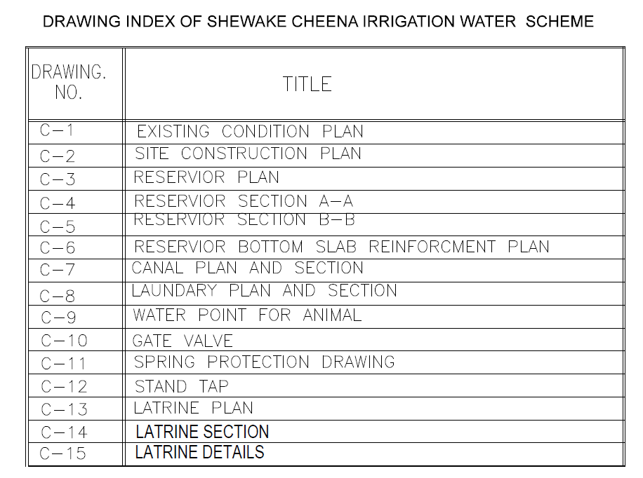

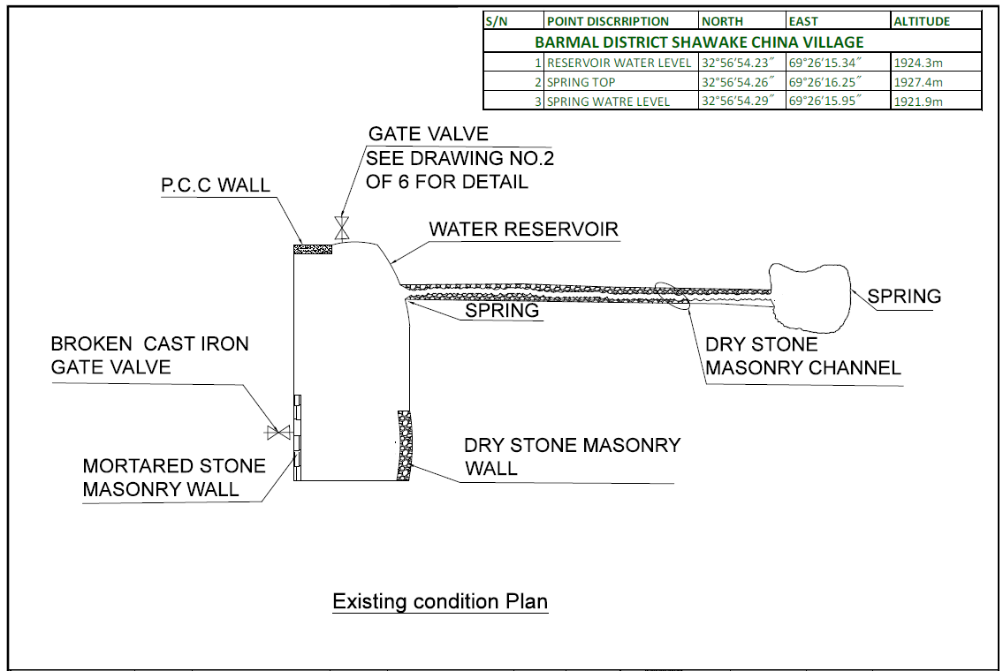

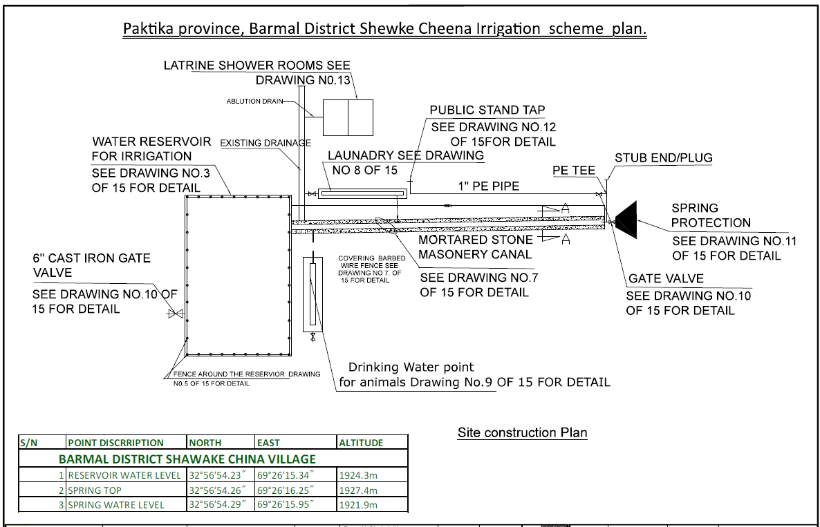

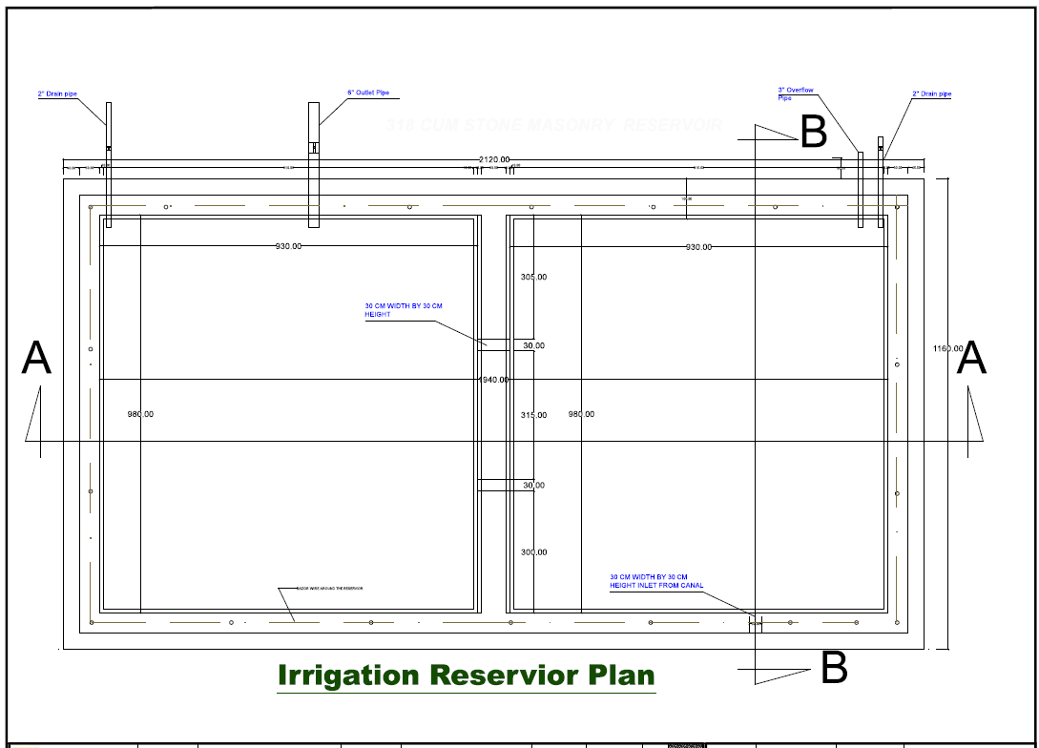

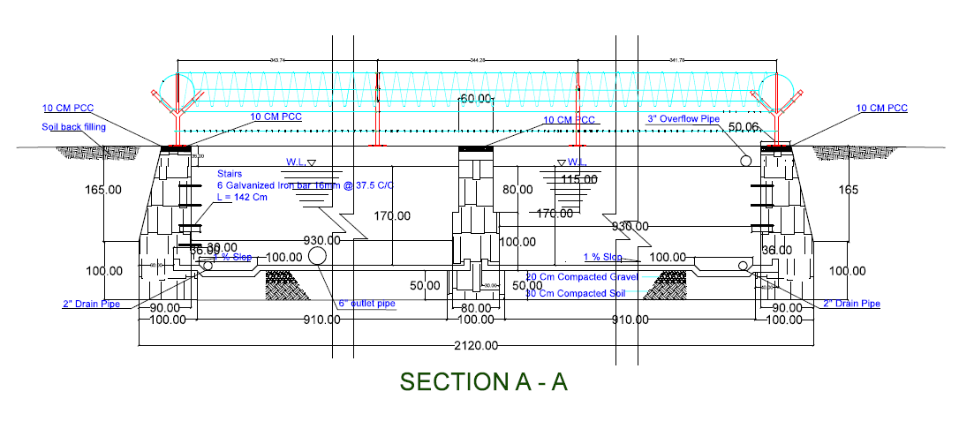

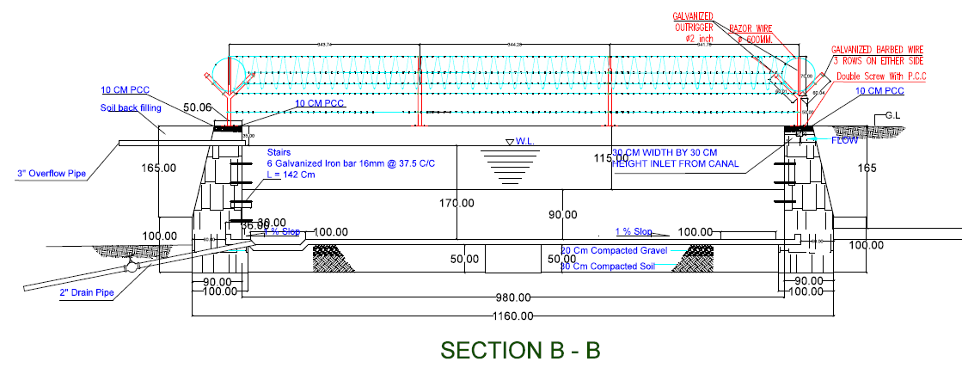

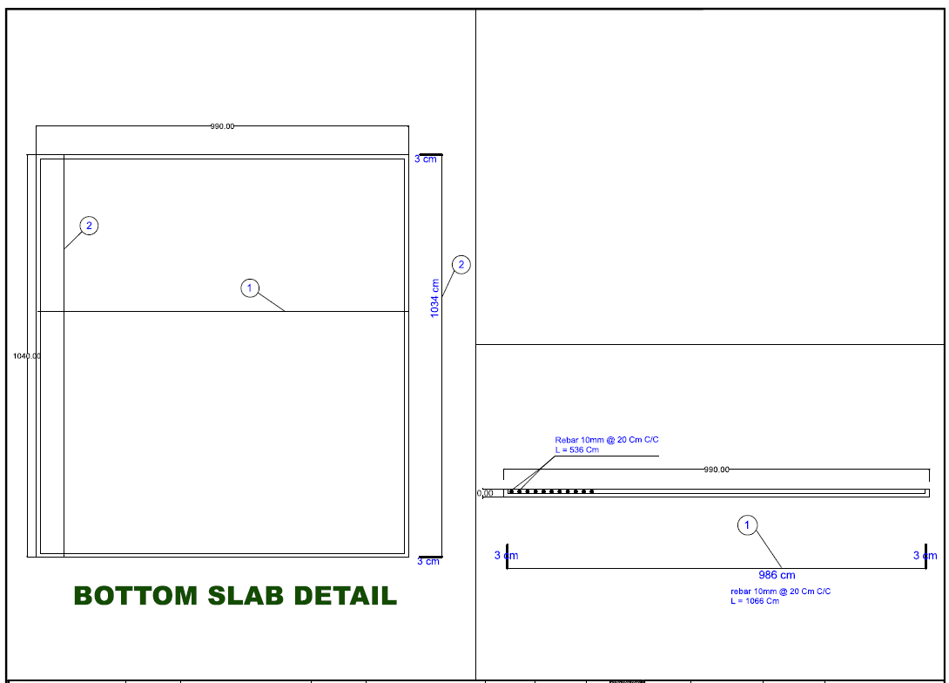

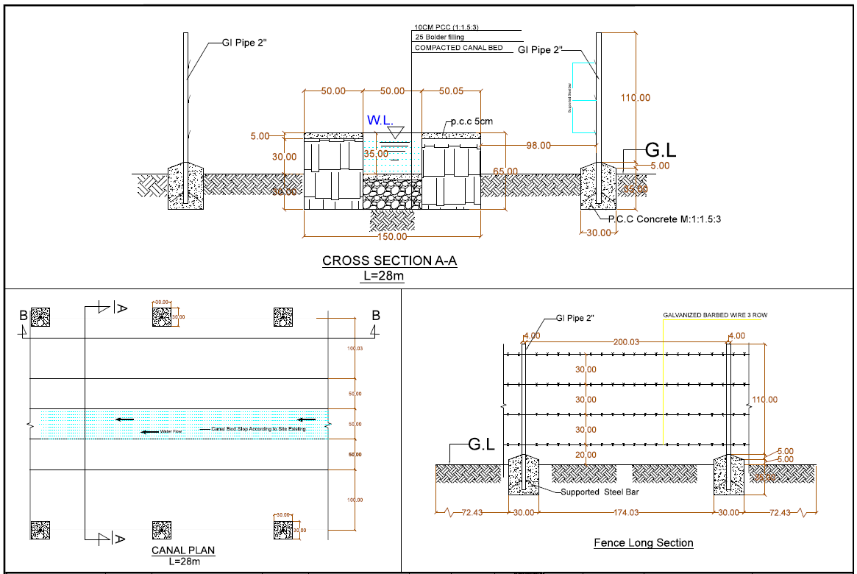

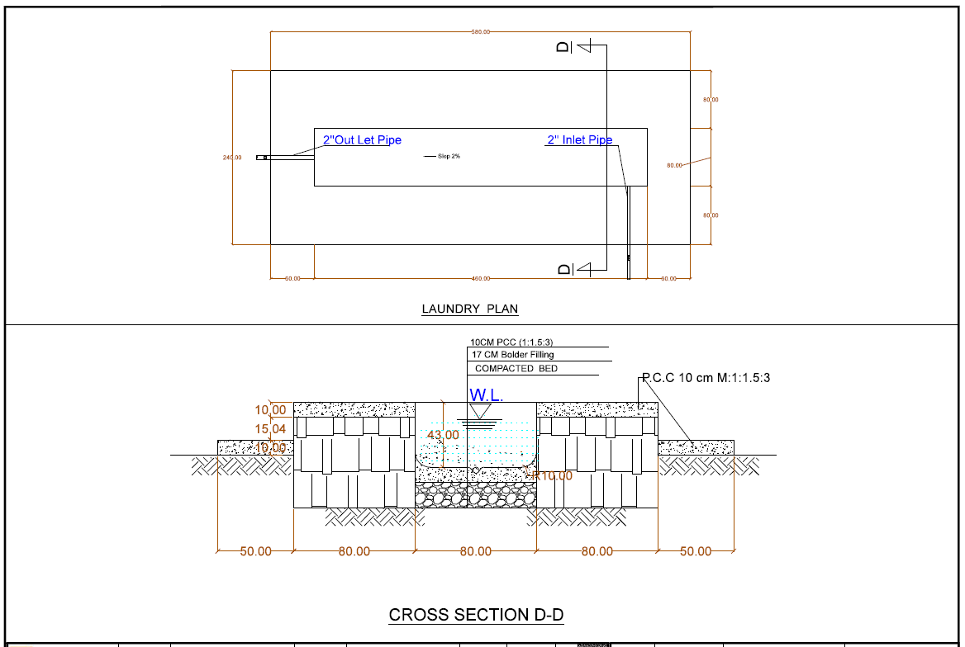
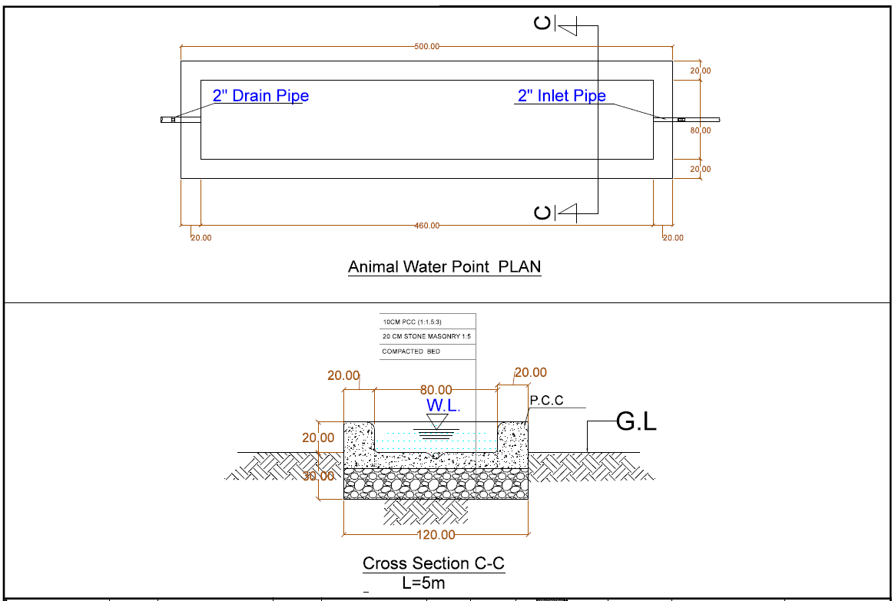

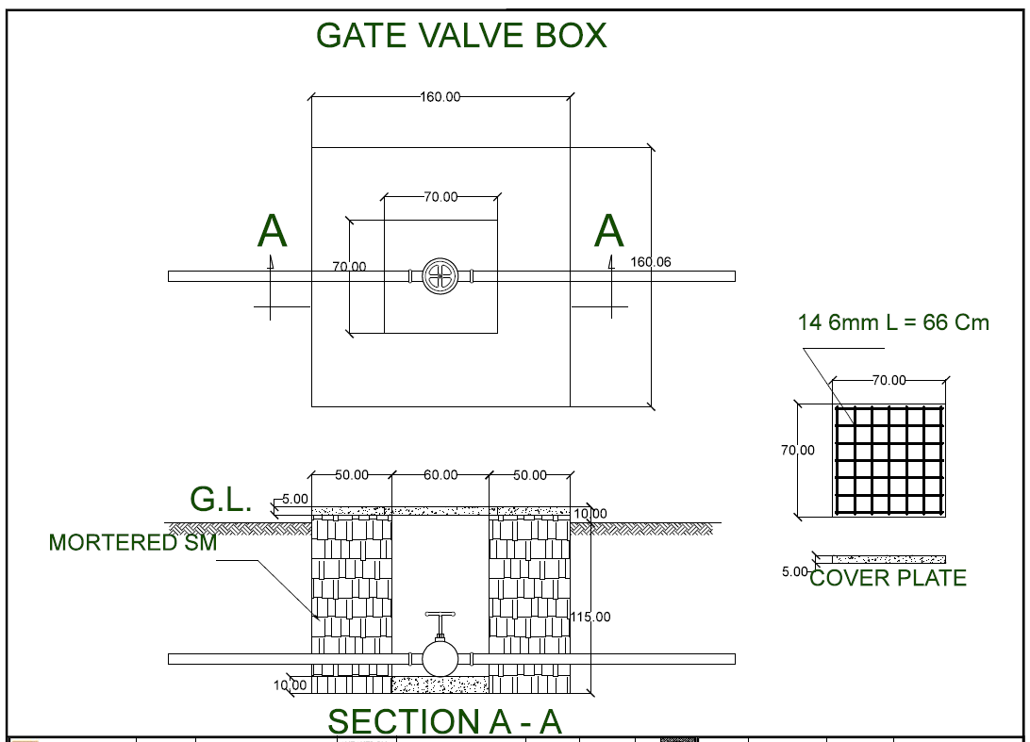
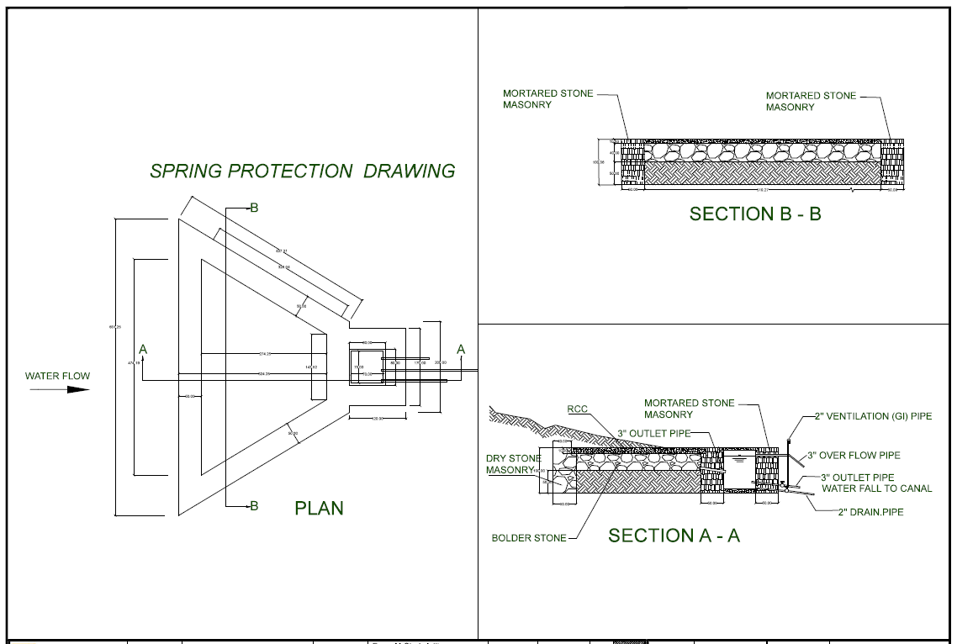

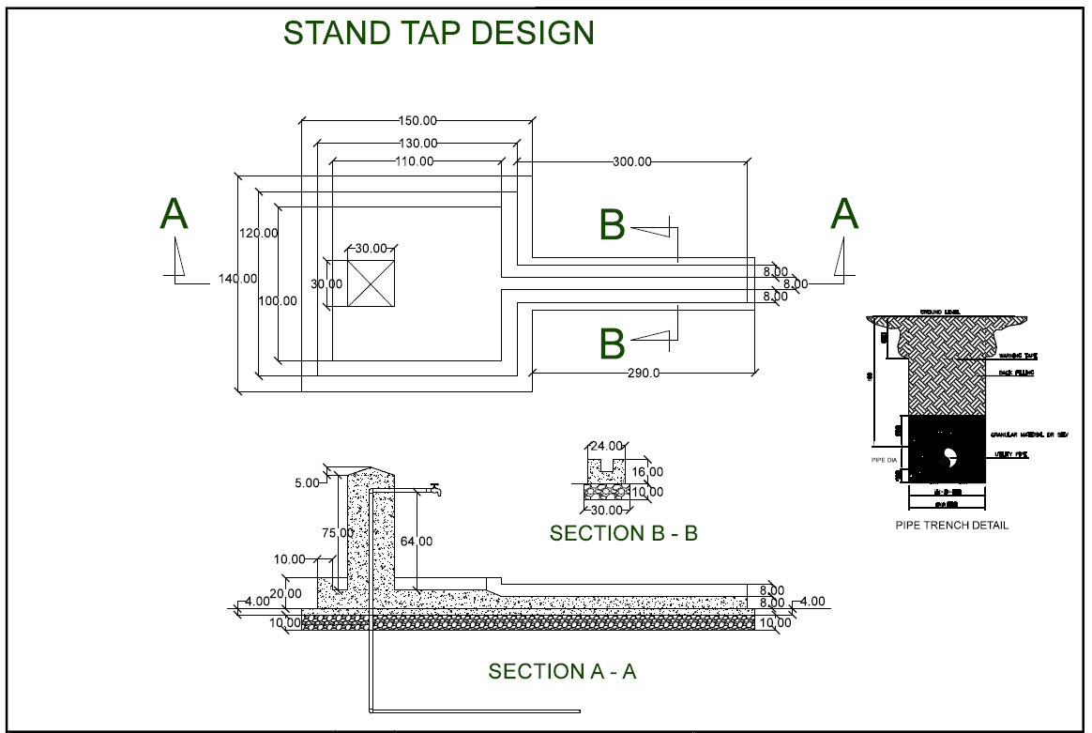

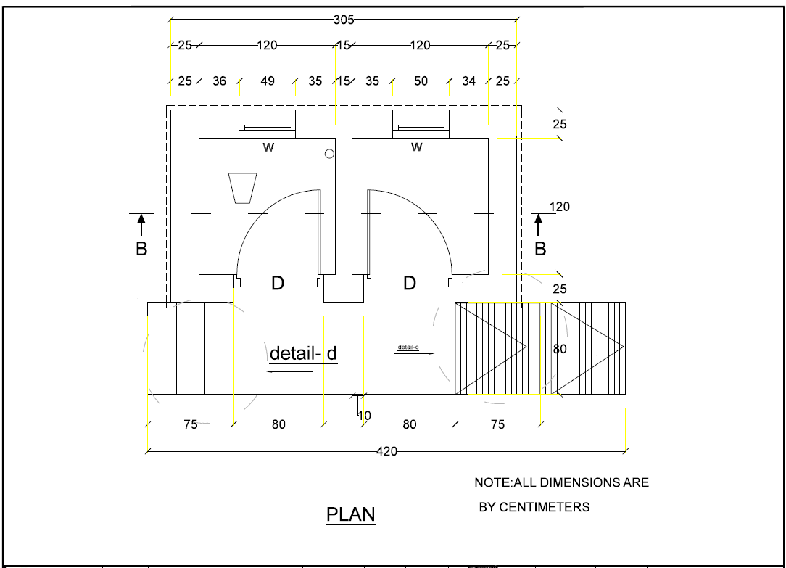

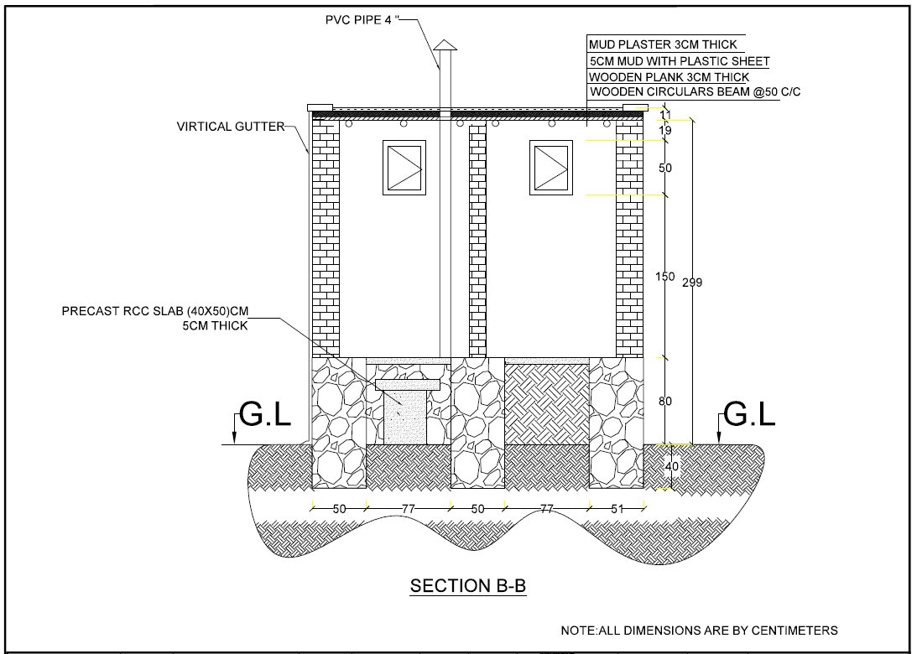

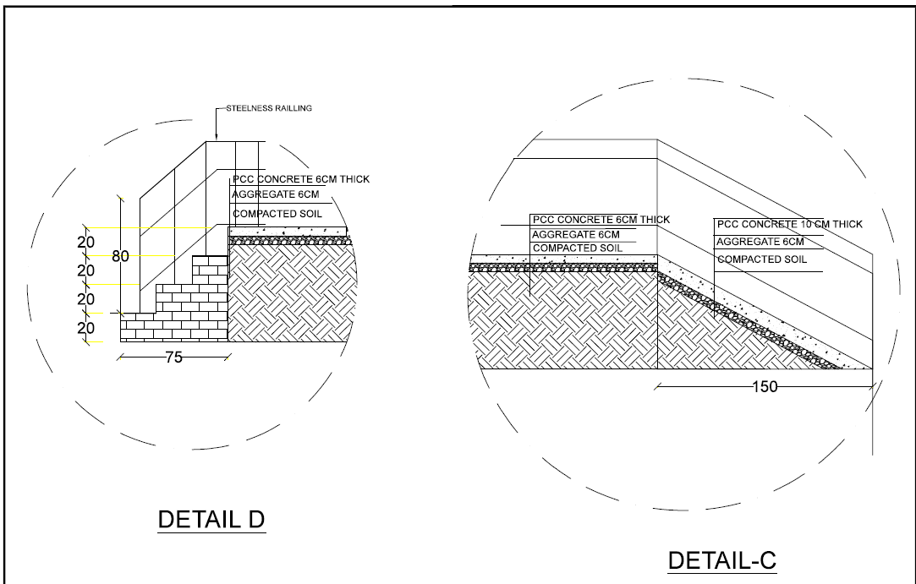

LOT 3 - CONSTRUCTION OF Water Supply Pipe Scheme in Bahram khel Village of Bermal District in Paktika Province.
Drawing as follows

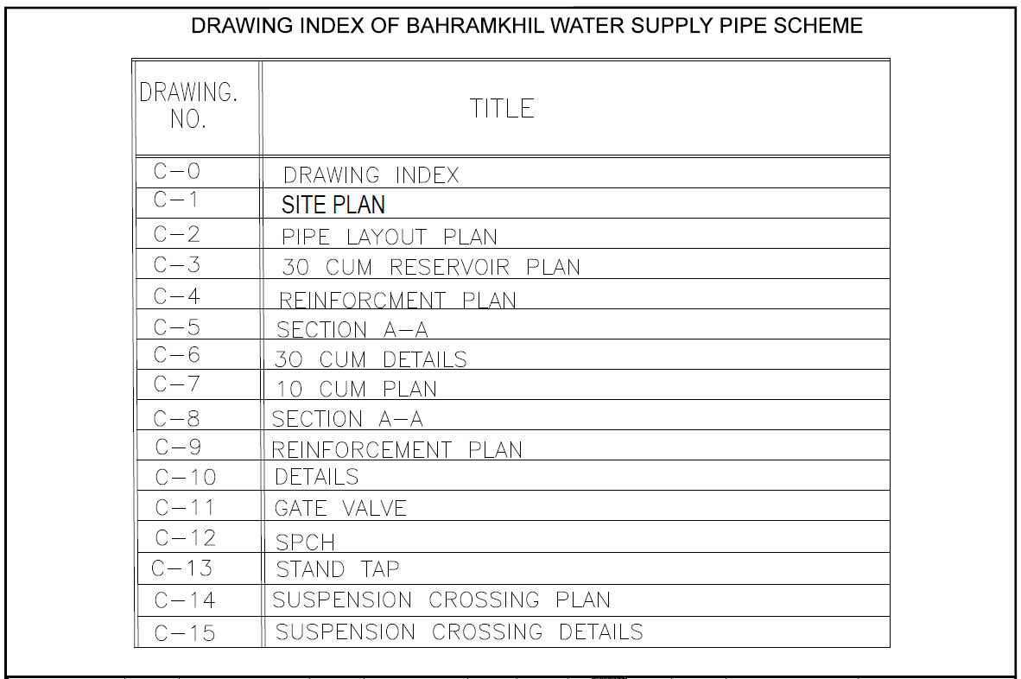

S/N | point/D | N | E | Altitude
 | IBRAHIM KHEL
1 | IBRAHIM KHEL SPR | 32°56′23.55" | 69°28′5.81" | 1849.2M
2 | IB HEL SIDE TOP | 32°56′4.55" | 69°27′26.97" | 1845.7m
3 | HEL SID SUBMERS | 32°56′4.92" | 69°27′29.87" | 1826.7m
4 | 13 | 32°56′38.58" | 69°27′43.68" | 1852.1m
5 | 12 | 32°56′30.67" | 69°27′39.46" | 1842.8m
6 | 11 | 32°56′21.26" | 69°27′40.49" | 1837.6m
7 | 10 | 32°56′20.26" | 69°27′38.80" | 1835.2m
8 | 1 | 32°56′20.86" | 69°28′4.31" | 1845.5m
9 | 2 | 32°56′14.46" | 69°27′59.98" | 1847.0m
10 | 3 | 32°56′11.31" | 69°27′48.51" | 1831.8m
11 | 4 | 32°56′5.86" | 69°27′36.68" | 1825.1m
12 | 5 | 32°56′11.09" | 69°27′23.49" | 1818.4m
13 | 6 | 32°56′13.67" | 69°27′20.91" | 1817.0m
14 | 7 | 32°56′16.76" | 69°27′17.21" | 1838.6m
15 | STP1 | 32°56′15.98" | 69°27′18.78" | 1835.5m
16 | STP2 | 32°56′11.44" | 69°27′15.98" | 1814.9m
17 | STP3 | 32°56′9.99" | 69°27′15.66" | 1820.4m
18 | STP4 | 32°56′8.92" | 69°27′14.30" | 1816.0m
19 | STP5 | 32°56′8.42" | 69°27′13.45" | 1811.9m
20 | STP6 | 32°56′9.25" | 69°27′13.38" | 1818.7m
21 | STP7 | 32°56′7.37" | 69°27′12.14" | 1815.2m

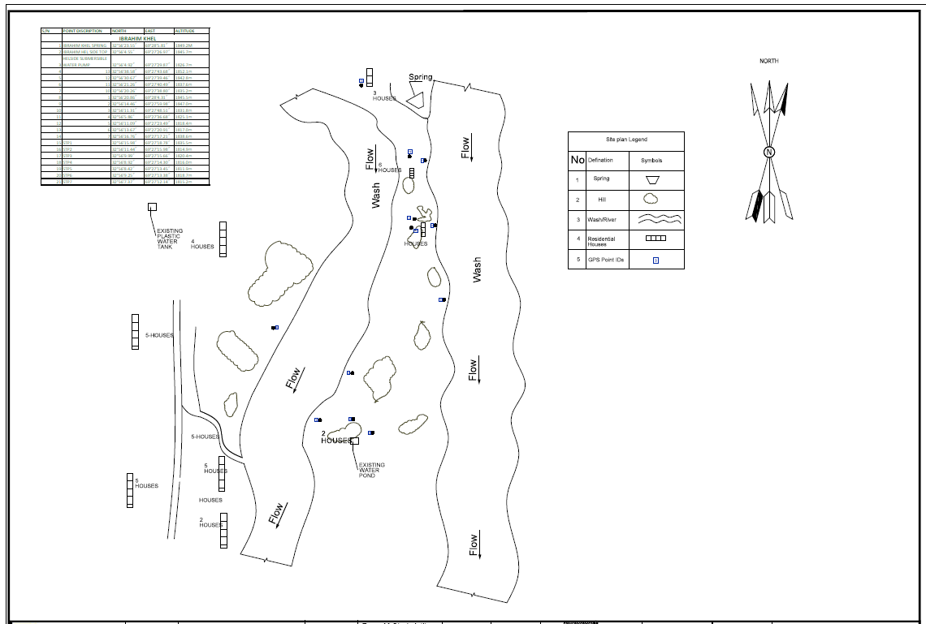

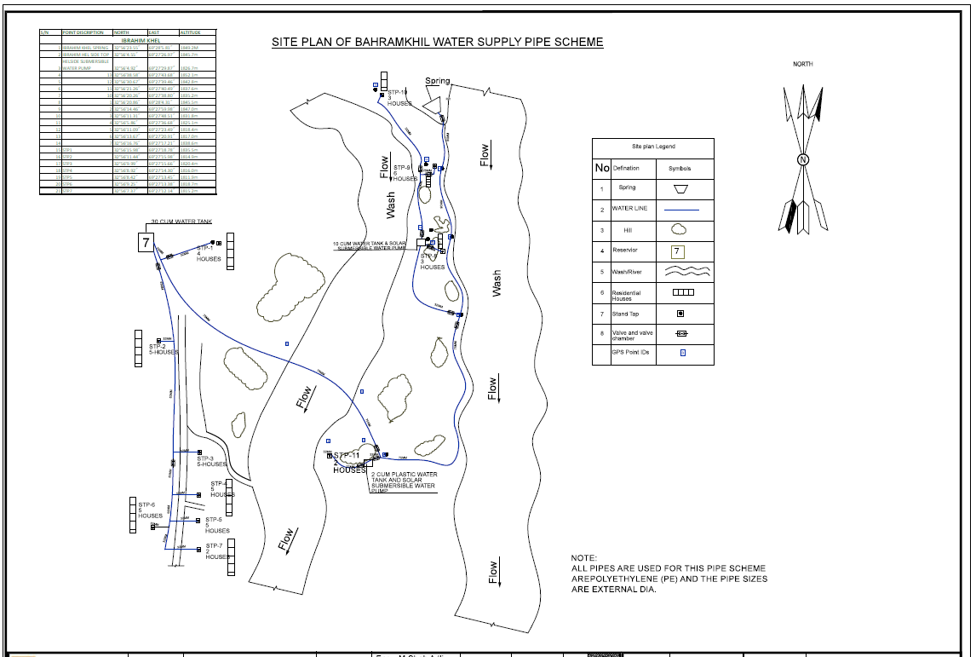

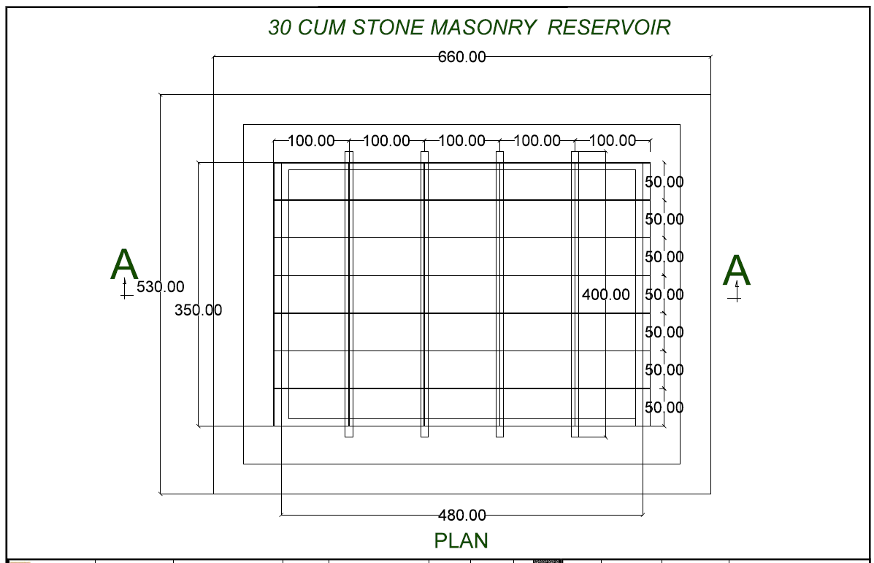

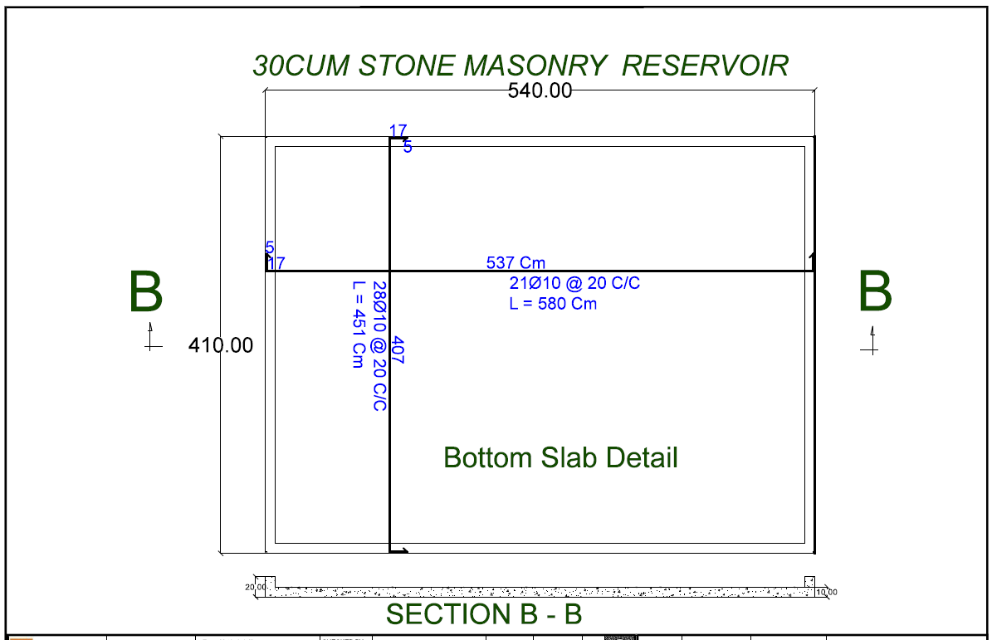

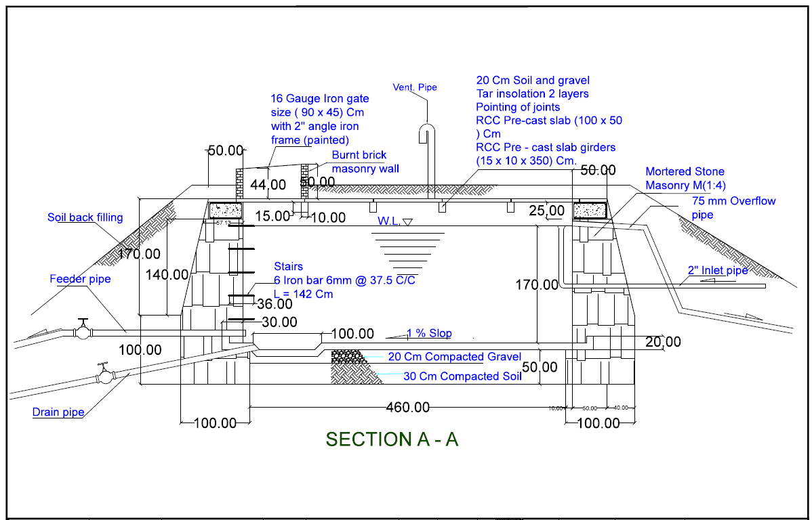

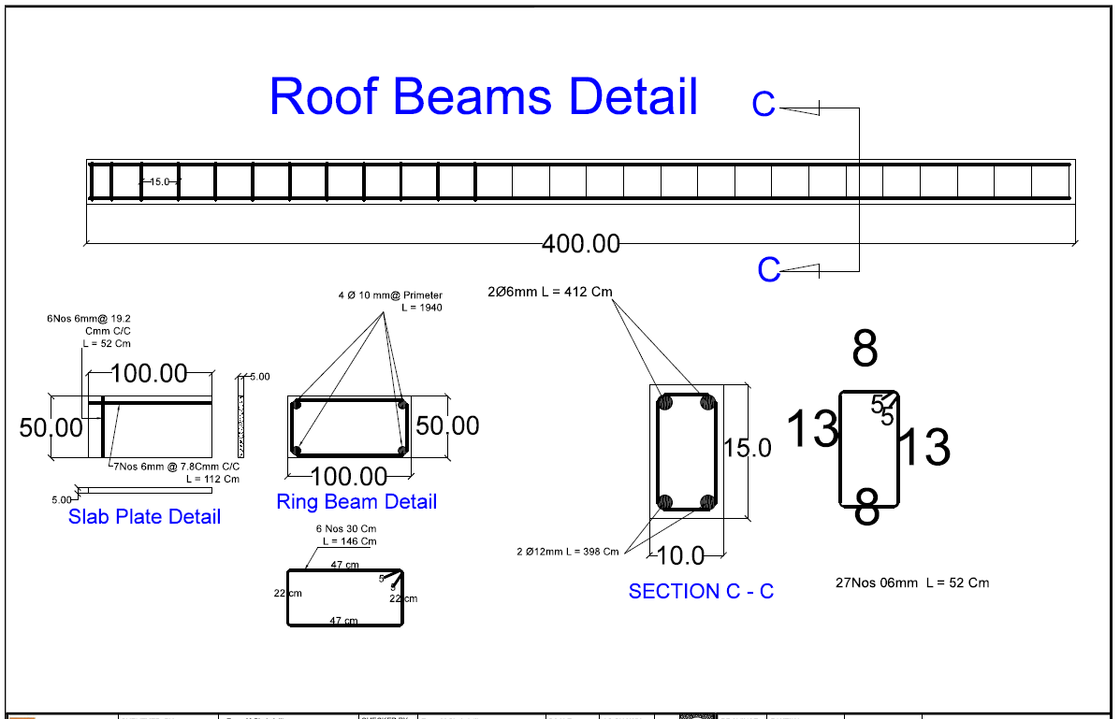

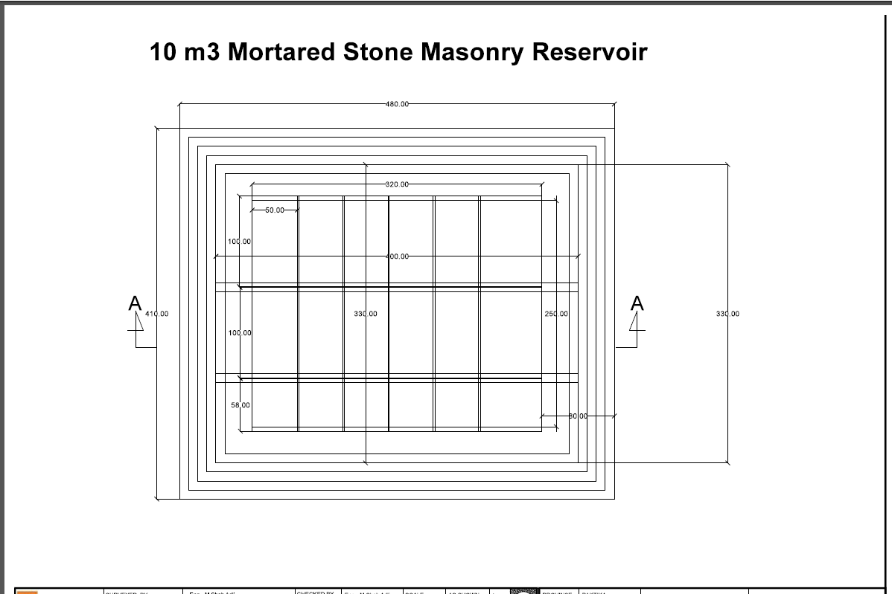

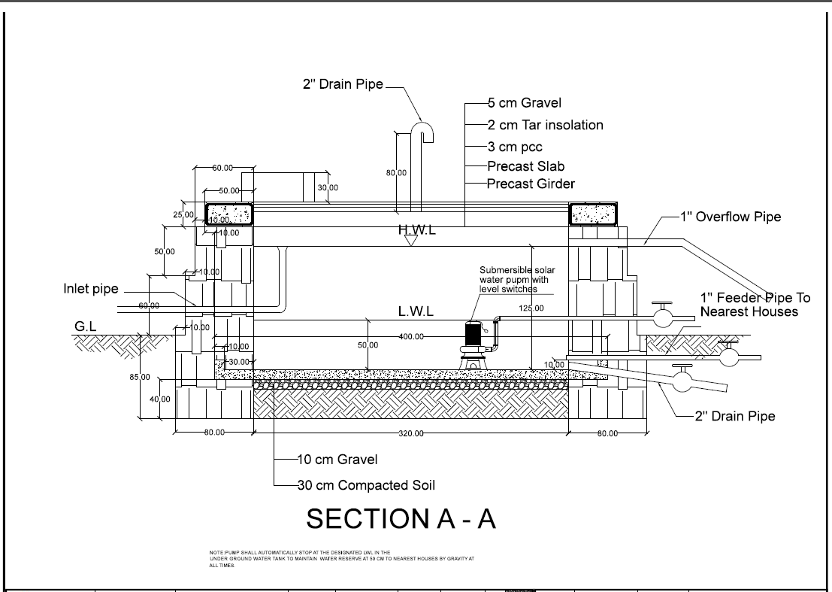

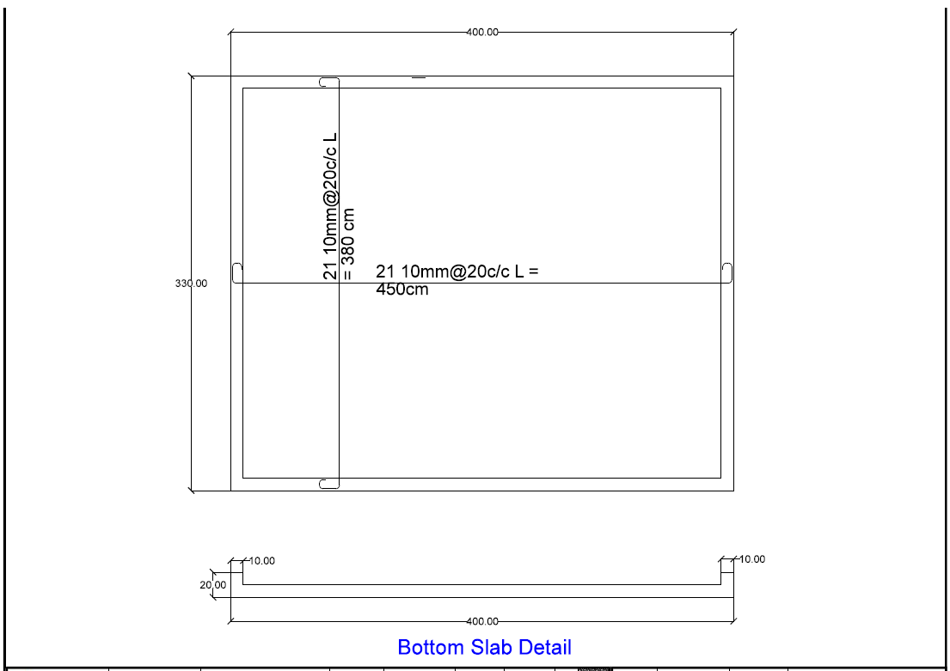

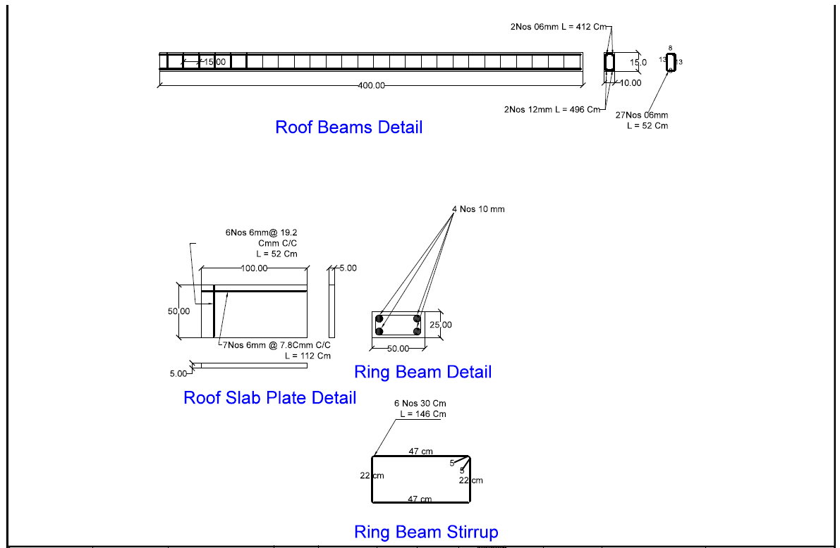

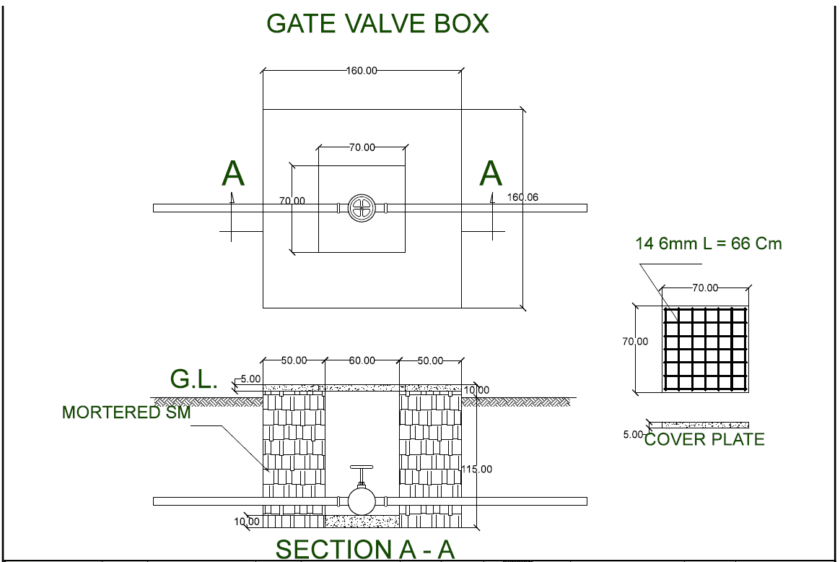

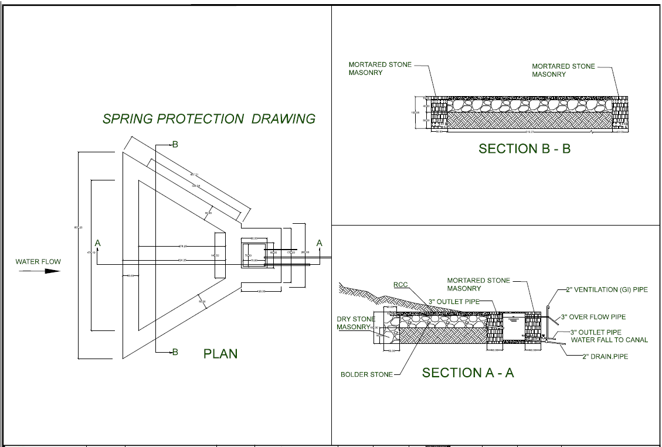

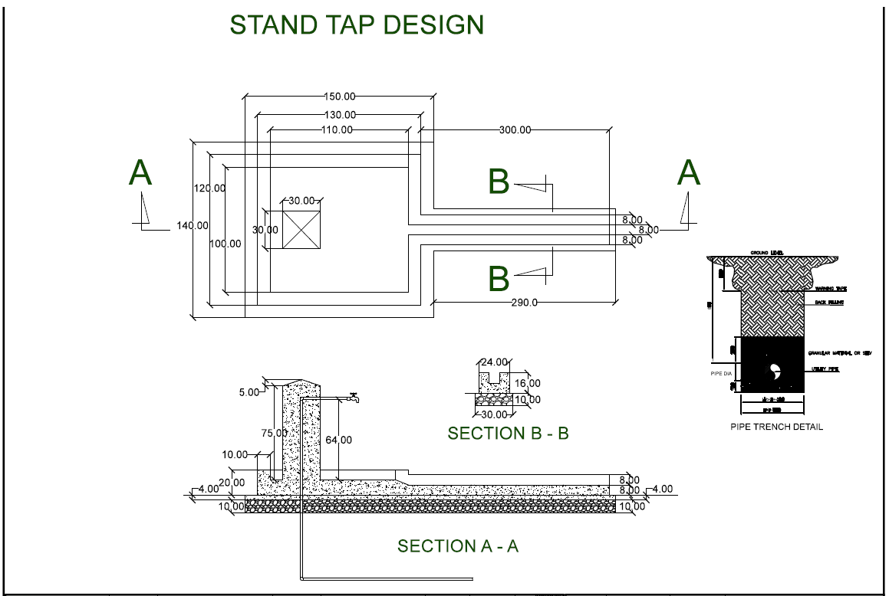

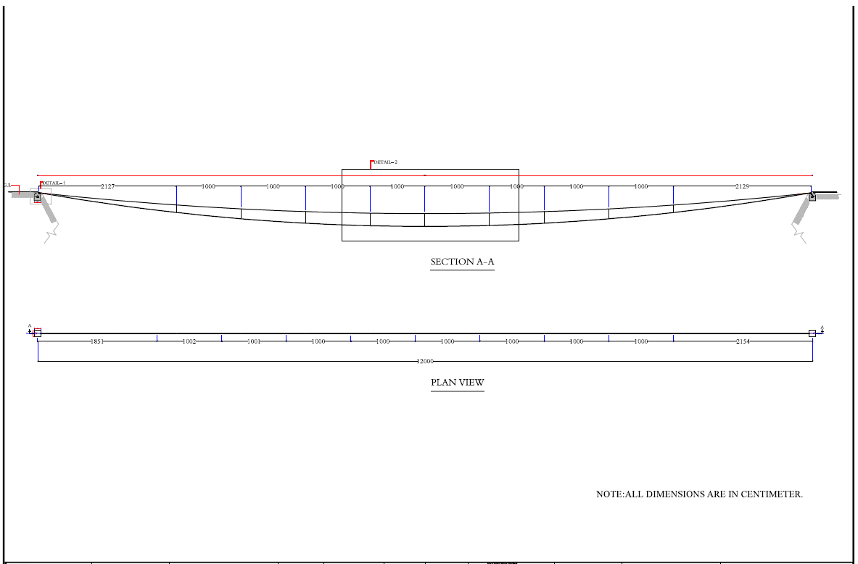

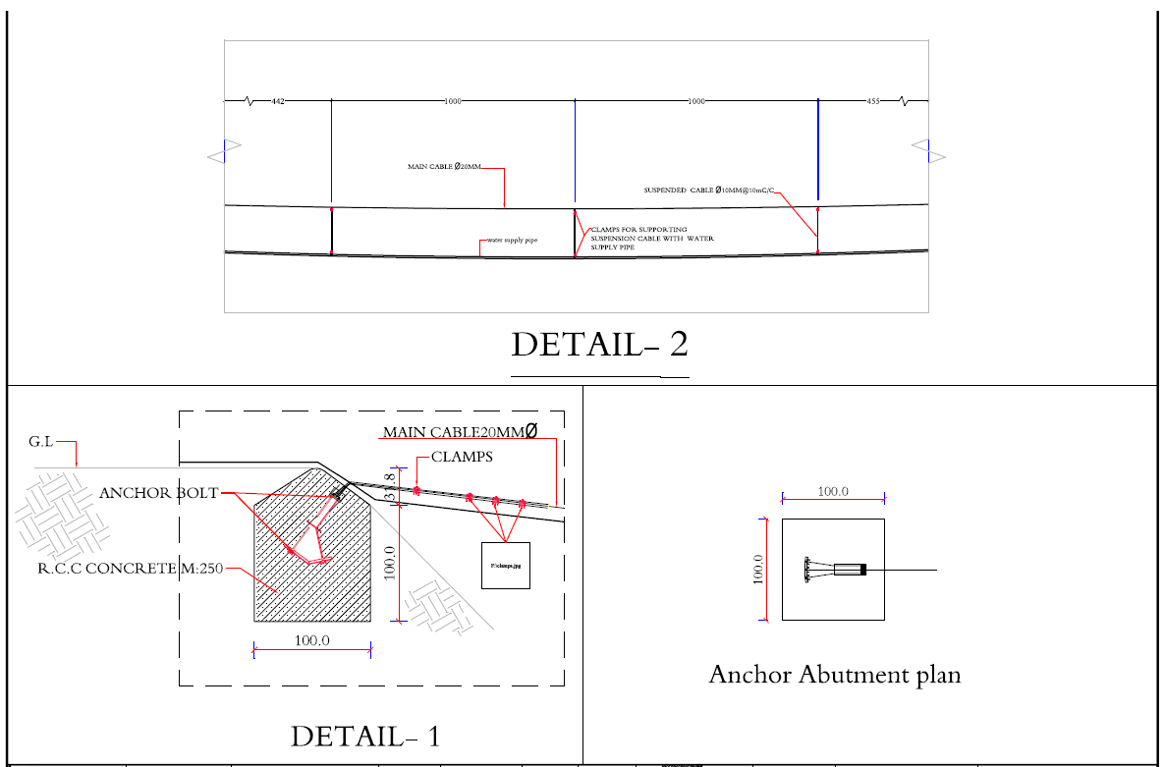

SECTION 5: BIDDING FORM

Please provide information against each requirement.
Additional rows can be inserted for all questions as necessary. If there is insufficient space to complete your answer in the space provided, please include on a separate attachment with a reference to the question.

- Bidder’s general business details
- General information

Company name:
Any other trading names of company:
Registered name of company (if different):
Nature of primary business/trade:
Primary contact name:
Job title:
Phone:
Email:
Registered Address:

Business licence number:
Country of registration
Registration date:
Expiry date:
Legal status of company (eg. partnership, private limited company, etc.)

- Owners/Managers
Please fill in the below table with the full names and the year of birth of the company’s owner(s) and manager(s)*:

Full name | Residential Address | Date of Birth

* Please note this information is necessary in order to conduct the vetting procedure referred to in clause 25 of the Invitation to Bid-General Terms and Conditions.

- Employees
Please list the employees who would be involved with NRC in the event of contract award:

Employee name | Job title | Role on NRC project | Phone | Email
1.
2.
3.
…

- Company bank account details:

Beneficiary name:
Beneficiary account no.:
Beneficiary Bank:
Bank branch:
SWIFT:
IBAN:
Bank address:

- References
Please provide details of at least 3 client references whom NRC may contact, preferably from NGOs and UN agencies, for similar related works:

Client/company name | Contact person | Phone | Email | Contract details (works, location, size, value, etc)
1.
2.
3.
…

- Equipment
Please provide details of any relevant machinery/equipment/vehicles owned by the company that would potentially be used for construction: (do not mention rented items):

Type of machinery/ equipment/ vehicles | Quantity
1.
2.
3.
4.
5.
6.
…

- Defects Liability/Guarantee Period
Please provide details below of the defect liability and guarantee period you offer on the works included in this contract:
NRC are seeking suppliers who can guarantee the works for 6 months and are able to provide a 5% performance bank guarantee before the contract is being awarded.
- In the event of contract award, please confirm you are able to guarantee the works for a period of six months.
- Yes
- No

- Bid Validity
Please confirm the validity of your bid below (in calendar days):

- Confirmation of Bidder’s compliance

We, the Bidder, hereby certify that our tender is a genuine offer and intended to be competitive and we confirm we are eligible to participate in public procurement and meet the eligibility criteria specified in the Invitation to Bid. We confirm that the prices quoted are fixed and firm for the duration of the validity period and will not be subject to revision or variation.

The following documents are included in our Bid: (please indicate which documents are included by ticking the boxes below).

Documents | included
Section 5: Bidding form; completed, signed and stamped | ☐
Section 6: Work Schedule; completed, signed and stamped | ☐
Section 7: Company Profile and Previous Experience; completed, signed and stamped | ☐
Section 8: Pricing Proposal; completed, signed and stamped | ☐
Section 9: Supplier’s ethical standards declaration; completed, signed and stamped | ☐
Copy of valid business licence and Tax Certificates | ☐

We understand that NRC is not bound to accept the lowest, or indeed any bid, received.
We agree that NRC may verify the information provided in this form itself or through a third party as it may deem necessary.

We confirm that NRC may in its consideration of our offer, and subsequently, rely on the statements made herein.
Name of Signatory: | Tel N°:
Title of Signatory: | Name of Company:
Signature & stamp: | Date of Signing:
 | Address:

SECTION 6
Work Schedule

Attach the work schedule here:
Schedule to include:
      - Duration of each sub-activity
      - Total duration of the works
LOT 1 - REHABILITATION, UPGRADING, DISINFECTING & CLEANING OF BOREWELLS for 50 UNITS
Lot 1 - Work Schedule for well rehabilitation for 50 Borewells |  | Week 1 | Week 2 | Week 3 | Week 4 | Week 5 | Week 6 | Week 7 | Week 8 | Week 9 | Week 10
A1 | Plain cement concrete (P.C.C)M:200( 1:1.5:3) for the apron concrete and drain
A2 | Pedestal slab M20 , Various dia , 15 cm thickness .
A3 | Pedestal (3 Legged) for Pamir Hand Pump (8 kg )
A4 | Body of Pump for Pamir Hand Pump.(18kg)
A5 | Cover of Head for Pamir Hand Pump. (2kg )
A6 | Handle for Pamir Hand Pump.(14kg)
A7 | PVC Pipe 3 m length with 2''diameter, Class C, wall thickness 4.5 mm (Kowsar) type.
A8 | pump rod , 10mm having two hooks and 3m/piece length
A9 | Rod Hangar with Pin best quality for Pamir Hand Pump
A10 | Goal bearing for Pamir Hand pump
A11 | Plastic rope for installation of 2'' PVC pipe Diameter 10mm
A12 | Rod Centralizer with standard size for Pamir Hand Pump
A13 | Steel pin size 14mm lenth 70cm
A14 | Glue for connecting of 2'' PVC pipe type(117 American)
A15 | Pump Cylinder long , 4.5 kg for Pamir Hand pump (Kowsar).
A16 | Nut and Bolts Standard size, for Pamir Hand Pump
A17 | Steel Cone thickness 3 mm for Pamir Hand Pump
A18 | Rubber Cone Standard size, for Pamir Hand Pump
A19 | Installation fee
A20 | Signboard or installation NRC Logo, made from steel with 20*15 cm

LOT 2 – WORK PLAN CONSTRUCTION OF SPRING, LATRINE & IRRIGATION OF WATER SUPPLY TANK

No | Description of Activities | Week 1 | Week 2 | Week 3 | Week 4 | Week 5 | Week 6 | Week 7 | Week 8 | Week 9 | Week 10 | Week 11 | Week 12
A | Work Plan for 318 m3 (318000 lit) Stone Masonry Water Reservoir
B | Work Plan for Spring Protection
C | Work Plan for Canal
D | Work Plan for Stand Tap
E | Work Plan for Gate Valve Vault
F | Work Plan For Water Transmission and Distribution lines
G | Work Plan For Latrine

LOT 3 - WORK PLAN CONSTRUCTION OF Water Supply Pipe Scheme in Bahram khel Village of Bermal District in Paktika Province.

No | Description of Activities | Week 1 | Week 2 | Week 3 | Week 4 | Week 5 | Week 6 | Week 7 | Week 8 | Week 9 | Week 10 | Week 11 | Week 12
A | Work Plan for 30 m3 (30000 lit) Stone Masonry Water Reservoir
B | Work Plan for 10 m3 (10000 lit) Stone Masonry Water Reservoir, Solar Water Pump, and Solar Panels
D | Work Plan for Spring Protection
E | Work Plan for Stand Tap
F | Work Plan for Gate Valve Vault
G | Work Plan For Distribution Line
H | Work Plan For Suspension Crossing

3. Detailed list of proposed Personnel/Manpower involved in the activities (e.g. engineers, site supervisors, foremen, masons, carpenters, plumbers, unskilled labors, etc.) with an estimate of the total man-day completed by each of the skills.

The Submission of the Manpower shall follow the below simple format:
# | Proposed Personnel/Manpower | # of workers allocated to this project
1
2
3
4
…

NOTE: The list shouldn’t be limited to this Form in regards to the number of proposed Key Personnel.
A comprehensive list has to be submitted adapting the Form to the necessary rows.

SECTION 7
COMPANY PROFILE AND PREVIOUS EXPERIENCE
The Bidder is requested to:
- Submit the Company Profile
- Complete the following Previous Experience Table listing the work or contracts undertaken in the past 5 years similar to the works required under this contract
- Submit evidences of previous experience in form of Contracts, Completion Certificates, Handover Documents etc.

# | Name of Project / Type of work | Total value of the performed works (.....) | Duration of the works contract | Starting date | Ending date | Contracting Authority ,Place & Point of Contact information ( email and mob#)
1
2
3
4
5
…
NOTE: The list shouldn’t be limited to this Form in regards to the number of works reported. A comprehensive list of the last 5 years’ experience has to be submitted adapting the Form to the necessary rows.
NRC may conduct reference checks for previous contracts completed

SECTION 8
BILL OF QUANTITIES
Preamble to Bill of Quantities
- NRC has the faculty to contract all or part of the requested supply and works, according to budget availability and are not obliged to select one supplier for all the works listed in this BoQ in Zazi maidan in Khost province. By quoting, the supplier warrants that the offered prices are valid even if the full order is not awarded of the locations in Khost province.

The supply and works should be the best available in the market;

The Bidder should submit supporting documents concerning the proposed construction materials and works (i.e. catalogues, models, brands, drawings, technical documentation, technical specifications, etc. of the offered items);

All the materials to supply and the works to execute must be approved by the NRC Representative, prior to delivery and execution.

Costs must include all duties, taxes and other levies payable by the contractor under the contract and all mobilization costs specified in section 3.

Bill of Quantities

LOT 1 - REHABILITATION, UPGRADING, DISINFECTING & CLEANING OF BOREWELLS
District: Gayan
Province:Paktika
Project Code: AFFM2223

S/N | POINT DESCRIPTION | NORTH | EAST | ALTITUDE
GAYAN DSTRICT VILLAGES
1 | MIR SAHEB | 32°58′55.85" | 69°22′9.48" | 2152.1m
2 | MIAMA SHEKH WALI | 32°59′6.85" | 69°22′2.22" | 2192.2m
3 | MAZAK | 32°58′49.24" | 69°22′14.89" | 2158.1m
4 | LOLAY | 32°58′55.75" | 69°22′6.68" | 2163.2m

LOT 1 - REHABILITATION, UPGRADING, DISINFECTING & CLEANING OF BOREWELLS

A | BoQ for well rehabilitation
No | Description of Activities | Unit | Quntity | unit cost  AF | Total cost  AF
A1 | Plain cement concrete (P.C.C)M:200( 1:1.5:3) for the apron concrete and drain | M3 | 67
A2 | Pedestal slab M20 , Variours dia , 15 cm thickness . | pc | 30
A3 | Pedestal (3 Legged) for Pamir Hand Pump (8 kg ) | PC | 40
A4 | Body of Pump for Pamir Hand Pump.(18kg) | PC | 18
A5 | Cover of Head for Pamir Hand Pump. (2kg ) | PC | 50
A6 | Handle for Pamir Hand Pump.(14kg) | PC | 35
A7 | PVC Pipe 3 m length with 2''diameter, Class C, wall thickness 4.5 mm (Kowsar) type. | PC | 215
A8 | pump rod , 10mm having two hooks and 3m/piece length | PC | 235
A9 | Rod Hangar with Pin best quality for Pamir Hand Pump | PC | 50
A10 | Goal bearing for Pamir Hand pump | Pair | 40
A11 | Plastic rope for installation of 2'' PVC pipe Diameter 10mm | Meter | 900
A12 | Rod Centrilizer with standard size for Pamir Hand Pump | PC | 700
A13 | Steel pin size 14mm lenth 70cm | PC | 50
A14 | Glue for connecting of 2'' PVC pipe type(117 American) | Kgr | 40
A15 | Pump Cylinder long , 4.5 kg for Pamir Hand pump (Kowsar). | PC | 32
A16 | Nut and Bolts Standard size, for Pamir Hand Pump | Pair | 70
A17 | Steel Cone thickness 3 mm for Pamir Hand Pump | PC | 40
A18 | Rubber Cone Standard size, for Pamir Hand Pump | PC | 50
A19 | Installation fee | PC | 50
A20 | Signboard or instalation NRC Logo, made from steel with 20*15 cm | PC | 50
Total price for fifty (50) bore well (AFN)

LOT 2 Bill of Quantity for Construction of Water Supply Pipe Scheme and Latrine in Shewki Cheena Village of Bermal District in Paktika Province

No | Description of Activities | Unit | QTY | Unit Cost  Afs | No of Units | Total Cost  Afs
A | BoQ for 318 m3 (318000 lit) Stone Masonry Water Reservoir
1 | Excavation for reservoir in ground type 3-5 کندن کاری در زمین قسم سوم الی پنجم | M3 | 537.95 |  | 1
2 | Back filling with soil and excavated material پر کاری خاک معه تپک کاری | M3 | 95.06 |  | 1
3 | Stone mesonry with cement-sand mortar M:1:5 سنگ کاری با مصالح سمنت و ریگ به مارک ذکر شده | M3 | 145.67 |  | 1
4 | Graveling with gravel size 12-15mm selected material per drawing جغل اندازی مطابق نقشه | M3 | 38.02 |  | 1
5 | Plain cement concrete(PCC), M150(1:2:4) کانکریت بدون سیخ با مارک ذکر شده | M3 | 3.72 |  | 1
6 | Reinforced cement Concrete (RCC), M200(1:1.5:3) including steel bars and shuttering according to drawings کانکریت سیخدار با مارک ذکر شده همرای قالب بندی ان مطابق نقشه | M3 | 20.80 |  | 1
7 | Plaster work with cement and sand M:1:3 for interior walls پلستر کاری خارجی با مارک ذکر شده | M2 | 167.28 |  | 1
8 | supply and installation of 2" Galvanised iron ladder for reservoir with all required activites | No | 1 |  | 1
9 | Supply and installation of galvanized iron or black steel, outlet, overflow and drain pipes, and fittings conforming to API 5L Grade 42 (Wall thickness 6.4 mm) all complete | LS | 1 |  | 1
10 | Black steel 2" pipe per API-5L with razor wires and barbed wires fence for the canal according to the drawing | M | 1 |  | 1
11 | Supply and installation of Cast Steel, Class 300 lbs ASME or eqivalent different size flanged gate valves for wash out and outlet pipes, per the drawing تهیه و نصب وال ها مطابق نقشه | No | 3 |  | 1
 | Sub-Total Cost for stone masonry water reservoir Afs
B | BoQ for Spring Protection
1 | Excavation in different ground type 3-4 کندن کاری در زمین قسم سوم الی چهارم | M3 | 253.96 |  | 1
2 | Stone mesonry with cement-sand mortar M:1:5 سنگ کاری با مصالح سمنت و ریگ به مارک ذکر شده | M3 | 7.18 |  | 1
3 | Reinforced cement Concrete (RCC), M200(1:1.5:3) including steel bars and shuttering according to drawings کانکریت سیخدار با مارک ذکر شده همرای قالب بندی ان مطابق نقشه | M3 | 1.51 |  | 1
4 | Plain cement concrete (PCC), M150(1:2:4) کانکریت بدون سیخ با مارک ذکر شده | M3 | 0.51 |  | 1
5 | Pointing for inside and outside of boundary wall with mortar M:1:3 انگاف کاری داخلی و بیرونی با مارک ذکر شده | M2 | 6.88 |  | 1
 | Sub-Total Cost for Sprring Protection - AFs
C | BoQ for Canal
1 | Excavation in different ground type 3-4 کندن کاری در زمین قسم سوم الی چهارم | M3 | 46.31 |  | 1
2 | Stone mesonry with cement-sand mortar M:1:5 سنگ کاری با مصالح سمنت و ریگ به مارک ذکر شده | M3 | 21.73 |  | 1
3 | Black steel 2" pipe per API-5L with razor wires and barbed wires fence at both sides of the canal according to the drawing | M | 1 |  | 1
4 | Plain cement concrete (PCC), M150(1:2:4) کانکریت بدون سیخ با مارک ذکر شده | M3 | 7.38 |  | 1
5 | Pointing for inside and outside of boundary wall with mortar M:1:3 انگاف کاری داخلی و بیرونی با مارک ذکر شده | M2 | 8.4 |  | 1
 | Sub-Total Cost for Canal (AFs)
D | BoQ for Stand Tap
1 | Excavation in different ground type 3-4 کندن کاری در زمین قسم سوم الی چهارم | M3 | 0.37 |  | 1
3 | Reinforced cement Concrete (RCC), M200(1:1.5:3) including steel bars and shuttering according to drawings کانکریت سیخدار با مارک ذکر شده همرای قالب بندی ان مطابق نقشه | M3 | 0.30 |  | 1
4 | Plain cement concrete (PCC), M150(1:2:4) کانکریت بدون سیخ با مارک ذکر شده | M3 | 0.15 |  | 1
5 | Plaster work with cement and sand M:1:3 for interior walls پلستر کاری خارجی با مارک ذکر شده | M2 | 4.88 |  | 1
 | Sub-Total Cost Stand Tap (Afs)
E | BoQ for Gate Valve Vault
1 | Excavation in different ground type 3-4 کندن کاری در زمین قسم سوم الی چهارم | M3 | 10.56 |  | 1
2 | Stone mesonry with cement-sand mortar M:1:5 سنگ کاری با مصالح سمنت و ریگ به مارک ذکر شده | M3 | 11 |  | 1
3 | Reinforced cement Concrete (RCC), M200(1:1.5:3) including steel bars and shuttering according to drawings کانکریت سیخدار با مارک ذکر شده همرای قالب بندی ان مطابق نقشه | M3 | 0.12 |  | 1
4 | Plain cement concrete (PCC), M150(1:2:4) کانکریت بدون سیخ با مارک ذکر شده | M3 | 0.73 |  | 1
5 | Pointing for inside and outside of boundary wall with mortar M:1:3 انگاف کاری داخلی و بیرونی با مارک ذکر شده | M2 | 12 |  | 1
 | Sub-Total Cost for Valve Vault (Afs)
F | BoQ For Water Transmission and Distribution lines
1 | Excavation of pipe trench for distribution pipes per pipe trench section drawing in ground type 3-6 کندن کاری در زمین قسم سوم الی ششم | M3 | 9.6 |  | 1
2 | Back filling of distribution pipe trenches per trench section drawing پر کاری خاک معه تپک کاری مطابق به قطع داده شده | M3 | 9.6 |  | 1
3 | Supplying, installation, laying and fitting in place of high density polyethylene pipe, per ISO 4427 or eqivalent (PE 100 PN 10 SDR 11), Outside diameter: 25mm, Best Quality پایپ پولی ایتلین به قطر خارجی ۲۵ ملی متر با فشار قابل برداشت ۱۶ بار | M | 30 |  | 1
4 | Supply and installation of Cast Steel, Class 300 lbs ASME or eqivalent Flanged Gate valve (good quality) Nominal diameter 3" best quality including valve vault/chamber including all fittings and accessories per the drawing گیت وال به مشخصات ذکر شده | No | 1 |  | 1
5 | Water tap and its connection from main pipe to nearbay latrine per drawing, with its all ASME/ANSI/ASTM or eqivalent accessories such as (3/4") saddle clump, elbow, male threaded adopter (MTA), gate valve, socket, and 3/4" GI pipe تهیه و تمدید نل از پایپ عمومی با تمامی ملحقات ان از قبیل سدل بست زانوخم اتصال ماده ُگیت وال فلکه شیردهن وساکت ُ با کیفیت عالی | No | 1 |  | 1
6 | Sign Board for Project لوحه یرای پروژه | No | 1 |  | 1
 | Sub-Total Cost for Water Transmission and Distribution lines (Afs)
G | BoQ For Latrine
1 | Excavation of Foundation in different ground type 3-4 کندن کاری در زمین قسم سوم الی چهارم | M3 | 1.64 |  | 2
2 | Back filling of foundation پر کاری خاک معه تپک کاری | M3 | 3 |  | 2
3 | Stone masonry of Foundation with cement-sand mortar M:1:5 سنگ کاری با مصالح سمنت و ریگ به مارک ذکر شده | M3 | 4.92 |  | 2
4 | Precast RCC Slab( 40x50x5)cm, M200(1:1.5:3) including steel bars and shuttering according to drawings کانکریت سیخدار با مارک ذکر شده همرای قالب بندی ان مطابق نقشه | M2 | 1 |  | 2
5 | Precast RCC slab for Latrine Floor (120X120x6)cm | No | 1 |  | 2
6 | Precast RCC Girder (20X10X80)cm), M200 (1:1.5:3) including steel bars and shuttering according to drawings کانکریت سیخدار با مارک ذکر شده همرای قالب بندی ان مطابق نقشه | No | 2 |  | 2
7 | PCC Concrete 1:2:4, M150(1:2:4) کانکریت بدون سیخ با مارک ذکر شده | M3 | 0.5 |  | 2
8 | Burnt Brick Wall with all requariment best quality | M3 | 5.8 |  | 2
9 | Internal Plaster with cement and sand M:1:3 for interior walls پلستر کاری خارجی با مارک ذکر شده | M2 | 24 |  | 2
10 | External plaster with cement and sand M:1:3 for interior walls پلستر کاری خارجی با مارک ذکر شده | M2 | 21 |  | 2
11 | Steel Door(80x200) cm 18 guage | No | 2 |  | 2
12 | window(40x50)cm With Mesh net | No | 2 |  | 2
13 | PVC Vent Pipe 4inch Sch.40 per ASTD-1785 With Fly screen | M | 4 |  | 2
14 | Stainless steel railing with high quality | M | 4.26 |  | 2
15 | PVC Elbow 90' Match the pipe size and standard | M | 2 |  | 2
16 | Roofing (installation Of wooden beam 10 cm and , wooden Plate thickness 2 cm,Plastic sheet and mud plaster with all requirement…etc | LS | 1 |  | 2
17 | Steel Gutter with all requirement accurding drawing | M | 2.2 |  | 2
 | Sub-Total Cost for Latrines (Afs)
 | Grand Total Cost (Afs) قیمت مجموعی پروژه

LOT 3 - Bill of Quantity for Water Supply Pipe Scheme in Bahram khel Village of Bermal District in Paktika Province.

A | BoQ for Water Well
No | Description of Activities | Unit | QTY | Unit Cost  AFs | Total Cost  Afs
A | BoQ for 30 m3 (30000 lit) Stone Masonry Water Reservoir
1 | Excavation for reservoir in ground type 3-5 کندن کاری در زمین قسم سوم الی پنجم | M3 | 3019.80
2 | Back filling with soil and excavated material پر کاری خاک معه تپک کاری | M3 | 39.37
3 | Stone mesonry with cement-sand mortar M:1:5 سنگ کاری با مصالح سمنت و ریگ به مارک ذکر شده | M3 | 44.09
4 | Graveling with gravel size 12-15mm selected material per drawing جغل اندازی مطابق نقشه | M3 | 3.17
5 | Plain cement concrete(PCC), M150(1:2:4) کانکریت بدون سیخ با مارک ذکر شده | M3 | 3.72
6 | Reinforced cement Concrete (RCC), M200(1:1.5:3) including steel bars and shuttering according to drawings کانکریت سیخدار با مارک ذکر شده همرای قالب بندی ان مطابق نقشه | M3 | 6.36
7 | Plaster work with cement and sand M:1:3 for interior walls پلستر کاری خارجی با مارک ذکر شده | M2 | 51.85
8 | supply and installation of 2" Galvanised iron ladder for reservoir with all required activites | No | 1
9 | Supply and installation of galvanized iron or black steel, outlet, overflow and drain pipes, and fittings conforming to API 5L Grade 42 (Wall thickness 6.4 mm) all complete | LS | 1
10 | Supply and installation of Cast Steel, Class 300 lbs ASME or eqivalent different size flanged gate valves for wash out and outlet, and drain pipes, per the drawing تهیه و نصب وال ها مطابق نقشه | No | 2
11 | Tar insulation of water tank roof | M2 | 27
 | Total Cost for 30000 Liters Water Reservoir (Afs)
B | BoQ for 10 m3 (10000 lit) Stone Masonry Water Reservoir, Solar Water Pump, and Solar Panels
1 | Excavation for reservoir in ground type 3-5 کندن کاری در زمین قسم سوم الی پنجم | M3 | 5.81
2 | Back filling with soil and excavated material پر کاری خاک معه تپک کاری | M3 | 2.55
3 | Stone mesonry with cement-sand mortar M:1:5 سنگ کاری با مصالح سمنت و ریگ به مارک ذکر شده | M3 | 28.23
4 | Graveling with gravel size 12-15mm selected material per drawing جغل اندازی مطابق نقشه | M3 | 0.75
5 | Plain cement concrete(PCC), M150(1:2:4) کانکریت بدون سیخ با مارک ذکر شده | M3 | 0.42
6 | Reinforced cement Concrete (RCC), M200(1:1.5:3) including steel bars and shuttering according to drawings کانکریت سیخدار با مارک ذکر شده همرای قالب بندی ان مطابق نقشه | M3 | 3.52
7 | Plaster work with cement and sand M:1:3 for interior walls پلستر کاری خارجی با مارک ذکر شده | M2 | 26.90
8 | supply and installation of 2" Galvanised iron ladder for reservoir with all required activites per drawing | No | 1
9 | Supply and installation of galvanized iron or black steel, outlet, overflow and drain pipes, and fittings conforming to API 5L Grade 42 (Wall thickness 6.4 mm) all complete | LS | 1
10 | Supply and installation of Cast Steel, Class 300 lbs ASME or eqivalent different size flanged gate valves for wash out and outlet, and drain pipes, per the drawing تهیه و نصب وال ها مطابق نقشه | No | 2
11 | Tar insulation of water tank roof | M2 | 14
12 | Supply and installation of submersible solar water pump 1.6 l/sec, total head: 25 m approximate power of 0.7 kW with inverter, control box in stainless steel (solar water pump LORNTZ, Grundfos, Franklin pump Europa GmbH/Germany SIEMENS as HYBRID solar pump inverter (siemens AG, Frauenauracher) or Equilvalent.  سولر پمپ گرندفوس ُ لورنز یا معادل ان طبق مشخصات داده شده فوق ساخت کشور جرمنی ُ هنگری یا ایتالوی باشد همراه با کنترولر | No | 1
13 | Solar panels 260-270watt (GF 270 watt, LORENTZ LC 260/24 V,LINUO Made in Germany (solar panels )260 watt or Equivalent in below specification and should German made or Eroupian Styandard) صفحه سولر از نوع سولر جی اف ُ لورنز ُ لینو و یا معادل ان باید که ساخت جرمنی و یا ستندرد اروپایی که دارای مشخصات داده شده باشد Range of ambient temperature: 233 .. 358 K Electrical data: Maximum power point voltage:37.4 V open circuit voltage: 38.4 V to 45.8 Max power point current: 5.49 to 8.37 A Module shortcut current: 8.94 A Maximum power output: 250 to 260 W solar module type: POLYCRYSTALLINE or MONOCRYSTALLINE CE Certificate for monocrystalline and monocrystalline, ISO 9001:2007 Certificate, DIN EN certificate, Efficiency for monocrystalline 18%-20%, Efficiency for polycrystalline 15%-18%, performance to 10 years (min 90% power output), performance to 20 years (min 80% power output), Visible lable on solar panel with technical specification | No | 4
 | Total Cost for stone masonry 10000 Liters water reservoir(Afs)
C | BoQ for 2 m3 (2000 lit) PVC Water Reservoir, Solar Water Pump, and Solar Panels
1 | Excavation in different ground type 3-4 کندن کاری در زمین قسم سوم الی چهارم | M3 | 8
2 | 2000 liters best quality PVC water tank includin all outlet, inlet, and draing pipes, and valves, fittings, and accessories complete in all aspects | LS | 1
3 | Supply and installation of submersible solar water pump 0.6 l/sec, total head: 24 m approximate power of 0.3 kW with inverter, control box in stainless steel (solar water pump LORNTZ, Grundfos, Franklin pump Europa GmbH/Germany SIEMENS as HYBRID solar pump inverter (siemens AG, Frauenauracher) or Equilvalent.  سولر پمپ گرندفوس ُ لورنز یا معادل ان طبق مشخصات داده شده فوق ساخت کشور جرمنی ُ هنگری یا ایتالوی باشد همراه با کنترولر | No | 1
3 | Solar panels 260-270watt (GF 270 watt, LORENTZ LC 260/24 V,LINUO Made in Germany (solar panels )260 watt or Equivalent in below specification and should German made or Eroupian Styandard) صفحه سولر از نوع سولر جی اف ُ لورنز ُ لینو و یا معادل ان باید که ساخت جرمنی و یا ستندرد اروپایی که دارای مشخصات داده شده باشد Range of ambient temperature: 233 .. 358 K Electrical data: Maximum power point voltage:37.4 V open circuit voltage: 38.4 V to 45.8 Max power point current: 5.49 to 8.37 A Module shortcut current: 8.94 A Maximum power output: 250 to 260 W solar module type: POLYCRYSTALLINE or MONOCRYSTALLINE CE Certificate for monocrystalline and monocrystalline, ISO 9001:2007 Certificate, DIN EN certificate, Efficiency for monocrystalline 18%-20%, Efficiency for polycrystalline 15%-18%, performance to 10 years (min 90% power output), performance to 20 years (min 80% power output), Visible lable on solar panel with technical specification | No | 2
 | Total Cost for PVC 2000 Liters water reservoir(Afs)
D | BoQ for Spring Protection
1 | Excavation in different ground type 3-4 کندن کاری در زمین قسم سوم الی چهارم | M3 | 13.96
2 | Stone mesonry with cement-sand mortar M:1:5 سنگ کاری با مصالح سمنت و ریگ به مارک ذکر شده | M3 | 7.18
3 | Dry Stone Massonry سنگ کاری بیدون مصالح سمنت و ریگ | M3 | 5.32
4 | Reinforced cement Concrete (RCC), M200(1:1.5:3) including steel bars and shuttering according to drawings کانکریت سیخدار با مارک ذکر شده همرای قالب بندی ان مطابق نقشه | M3 | 1.51
5 | Plain cement concrete (PCC), M150(1:2:4) کانکریت بدون سیخ با مارک ذکر شده | M3 | 0.51
6 | Pointing for inside and outside of boundary wall with mortar M:1:3 انگاف کاری داخلی و بیرونی با مارک ذکر شده | M2 | 6.88
 | Total Cost for Sprring Protection (Afs)
E | BoQ for Stand Tap
1 | Excavation in different ground type 3-4 کندن کاری در زمین قسم سوم الی چهارم | M3 | 5.52
2 | Reinforced cement Concrete (RCC), M200(1:1.5:3) including steel bars and shuttering according to drawings کانکریت سیخدار با مارک ذکر شده همرای قالب بندی ان مطابق نقشه | M3 | 4.47
3 | Plain cement concrete (PCC), M150(1:2:4) کانکریت بدون سیخ با مارک ذکر شده | M3 | 2.31
4 | Plaster work with cement and sand M:1:3 for interior walls پلستر کاری خارجی با مارک ذکر شده | M2 | 73.14
 | Total Cost Stand Taps (Afs)
F | BoQ for Gate Valve Vault
1 | Excavation in different ground type 3-4 کندن کاری در زمین قسم سوم الی چهارم | M3 | 33.79
2 | Stone mesonry with cement-sand mortar M:1:5 سنگ کاری با مصالح سمنت و ریگ به مارک ذکر شده | M3 | 35.20
3 | Reinforced cement Concrete (RCC), M200(1:1.5:3) including steel bars and shuttering according to drawings کانکریت سیخدار با مارک ذکر شده همرای قالب بندی ان مطابق نقشه | M3 | 0.39
4 | Plain cement concrete (PCC), M150(1:2:4) کانکریت بدون سیخ با مارک ذکر شده | M3 | 2.34
5 | Pointing for inside and outside of boundary wall with mortar M:1:3 انگاف کاری داخلی و بیرونی با مارک ذکر شده | M2 | 38.40
 | Total Cost for Gate Valve Vaults (Afs)
G | BoQ For Distribution Line
1 | Excavation of pipe trench for distribution pipes per pipe trench section drawing in ground type 3-6 کندن کاری در زمین قسم سوم الی ششم | M3 | 3020
2 | Back filling of distribution pipe trenches per trench section drawing پر کاری خاک معه تپک کاری مطابق به قطع داده شده | M3 | 3020
4 | Supplying, installation, laying and fitting in place of high density polyethylene pipe, per ISO 4427, eqivalent (PE 100 PN 10 SDR 11), Outside diameter:25mm, Best Quality پایپ پولی ایتلین به قطر خارجی ۲۵ ملی متر با فشار قابل برداشت ۱۶ بار | M | 30
5 | Supplying, installation, laying and fitting in place of high density polyethylene pipe, per ISO 4427, eqivalent (PE 100 PN 10 SDR 11), Outside diameter:32mm, Best Quality پایپ پولی ایتلین به قطر خارجی ۳۲ ملی متر با فشار قابل برداشت ۱۶ بار | M | 2273
6 | Supplying, installation, laying and fitting in place of high density polyethylene pipe, per ISO 4427 or eqivalent (PE 100 PN 10 SDR 17),Outside diameter: 50mm, Best Quality including all fittings and accessories پایپ پولی ایتلین به قطر خارجی ۵۰ ملی متر با فشار قابل برداشت ۱۰ بار | M | 50
7 | Supplying, installation, laying and fitting in place of high density polyethylene pipe, per ISO 4427 or eqivalent (PE 100 PN 10 SDR 17),Outside diameter:63mm, Best Quality including all fittings and accessories پایپ پولی ایتلین به قطر خارجی ۶۳ ملی متر با فشار قابل برداشت ۱۰ بار | M | 280
8 | Supplying, installation, laying and fitting in place of high density polyethylene pipe, per ISO 4427 or (PE 100 PN 10 SDR 17),Outside diameter: 75mm, Best Quality including all fittings and accessories پایپ پولی ایتلین به قطر خارجی ۷۵ ملی متر با فشار قابل برداشت ۱۰ بار | M | 1550
9 | Supplying, installation, laying and fitting in place of high density polyethylene pipe, per ISO 4427 or eqivalent (PE 100 PN 10 SDR 17),Outside diameter: 90mm, Best Quality including all fittings and accessories پایپ پولی ایتلین به قطر خارجی ۹۰ ملی متر با فشار قابل برداشت ۱۰ بار | M | 850
10 | Supply and installation of Cast Steel, Class 300 lbs ASME or eqivalent Flanged Gate valve (good quality) Nominal diameter 3" best quality including all fittings and accessories per the drawing گیت وال به مشخصات ذکر شده | No | 1
11 | Supply and installation of Cast Steel, Class 300 lbs ASME or eqivalent Flanged Gate valve (good quality) Nominal diameter 2 1/2" best quality including all fittings and accessories per the drawing گیت وال به مشخصات ذکر شده | No | 2
12 | Supply and installation of Cast Steel, Class 300 lbs ASME or eqivalent Flanged Gate valve (good quality) Nominal diameter 2 " best quality including all fittings and accessories per the drawing گیت وال به مشخصات ذکر شده | No | 3
13 | Supply and installation of Cast Steel, Class 300 lbs ASME or eqivalent Flanged Gate valve (good quality) Nominal diameter 1" best quality including all fittings and accessories per the drawing گیت وال به مشخصات ذکر شده | No | 7
14 | Water tap and its connection from main pipe to public point per drawing, with its all ASME/ANSI/ASTM or eqivalent accessories such as (1") saddle clump, elbow, male threaded adopter (MTA), gate valve, socket, Tee for future connection and 1" GI pipe تهیه و تمدید نل از پایپ عمومی با تمامی ملحقات ان از قبیل سدل بست زانوخم اتصال ماده ُگیت وال فلکه شیردهن وساکت ُ با کیفیت عالی | No | 15
15 | Sign Board for Project لوحه یرای پروژه | No | 1
 | Total Cost for Distribution Line (Afs)
H | BoQ For Suspension Crossing
1 | Excavation of pipe trench for distribution pipes per pipe trench section drawing in ground type 3-6 کندن کاری در زمین قسم سوم الی ششم | M3 | 2
2 | Reinforced cement Concrete (RCC), M200(1:1.5:3) including steel bars and shuttering according to drawings کانکریت سیخدار با مارک ذکر شده همرای قالب بندی ان مطابق نقشه | M3 | 2
3 | Supply and installation of 20 mm best quality steel reinforced cable as per drawing | M | 120
4 | Supply and installation of 10 mm best quality steel reinforced cable as per drawing | M | 20
5 | Supply and installation of anchors, anchor bolts, and u-bolts including all fittings and accessories complete in all aspects per drawing and site requirements | LS | 1
 | Total Cost for Suspension Crossing (Afs)
 | Grand Total Cost (Afs) قیمت مجموعی پروژه

NOTE: In case of discrepancy between BoQs and Drawings, the BoQs will prevail. In case of discrepancy between drawings, the one at larger scale will prevail.

Prepared by:
Name:
Position:
Signature:
Date:
Stamp:

SECTION 9
SUPPLIER’S ETHICAL STANDARDS DECLARATION

NRC as a humanitarian organization expects its suppliers and contractors to have high ethical standards. Any organization supplying goods to NRC valued at over 10,000 USD (or equivalent) in one year must sign this declaration. This declaration will be kept on file for a period of 10 years and should be updated every year or more often as appropriate.

NRC staff may perform spot checks to verify that these standards are adhered to. Should NRC deem that the supplier fails to meet, or is not taking appropriate steps to meet, these standards, any and all contracts and agreements with NRC may be terminated.

Anyone doing business with Norwegian Refugee Council shall as a minimum.
- Comply with all laws and regulations in effect in the country or countries of business.
- Meet the ethical standards as listed below; or
- Positively agree to the standards and be willing to implement changes in their organization.

- Anti-corruption and suppliers compliance with laws and regulations:
  - The supplier confirms that it is not involved in any form of corruption.
  - Where any potential conflict of interest exists between the supplier or any of the suppliers staff members with any NRC staff member, the supplier shall notify NRC in writing of the potential conflict. NRC shall then determine whether action is required. A conflict of interest can be due to a relationship with a staff member such as close family etc.
  - The supplier will immediately notify senior NRC management if exposed for alleged corruption by representatives of NRC.
  - The supplier shall be registered with the relevant government authority with regard to taxation.
  - The supplier shall pay taxes according to all applicable national laws and regulations.
  - The supplier warrants that it is not involved in the production or sale of any weapons including anti-personnel mines.

- Conditions related to the employees:
  - No workers in our company will be forced, bonded or involuntary prison workers.
  - Workers shall not be required to lodge “deposits” or identity papers with their employer and shall be free to leave their employer after reasonable notice.
  - Workers, without distinction, shall have the right to join or form trade unions of their own choosing and to bargain collectively.
  - Persons under the age of 18 shall not be engaged in work which is hazardous to their health or safety, including night work.
  - Employers of persons under the age of 18 must ensure that the working hours and nature of the work does not interfere with the child’s opportunity to complete his/ her education.
  - There shall be no discrimination at the work place based on ethnic background, religion, age, disability, gender, marital status, sexual orientation, union membership or political affiliation.
  - Measures shall be established to protect workers from sexually intrusive, threatening, insulting or exploitative behavior, and from discrimination or termination of employment on unjustifiable grounds, e.g. marriage, pregnancy, parenthood or HIV status.
  - Physical abuse or punishment, or threats of physical abuse, sexual or other harassment and verbal abuse, as well as other forms of intimidation, shall be prohibited.
  - Steps shall be taken to prevent accidents and injury to health arising out of, associated with, or occurring in, the course of work, by minimizing, so far as is reasonably practicable, the causes of hazards inherent in the working environment.
  - Wages and benefits paid for a standard working week shall meet, at a minimum, national legal standards or industry benchmark standards, whichever is higher. Wages should always be enough to meet basic needs.
  - Working hours shall comply with national laws and benchmark industry standards, whichever affords greater protection. It is recommended that working hours do not exceed 48 hours per week (8 hours per day).
  - Workers shall be provided with at least one day off for every 7 day period.
  - All workers are entitled to a contract of employment that shall be written in a language they understand.
  - Workers shall receive regular and documented health and safety training, and such training shall be repeated for new workers.
  - Access to clean toilet facilities and to potable water, and, if appropriate, sanitary facilities for food storage shall be provided.
  - Accommodation, where provided, shall be clean, safe and adequately ventilated, and shall have access to clean toilet facilities and potable water.
  - No Deductions from wages shall be made as a disciplinary measure.

- Environmental conditions:
  - Production and extraction of raw materials for production shall not contribute to the destruction of the resources and income base for marginalized populations, such as in claiming large land areas or other natural resources on which these populations are dependent.
  - Environmental measures shall be taken into consideration throughout the production and distribution chain ranging from the production of raw material to the consumer sale. Local, regional and global environmental aspects shall be considered. The local environment at the production site shall not be exploited or degraded by pollution.
  - National and international environmental legislation and regulations shall be respected.
  - Hazardous chemicals and other substances shall be carefully managed in accordance with documented safety procedures.

We, the undersigned verify that we are in compliance with all applicable laws and regulations and meet the ethical standards as listed above, or positively agree to these ethical standards and are willing to implement necessary changes in the organization.

DATE: _________________

NAME OF SUPPLIER/COMPANY: _____________________________________________

NAME OF REPRESENTATIVE: _____________________________________________

SIGNATURE: _____________________________________________

COMPANY STAMP: _____________________________________________

