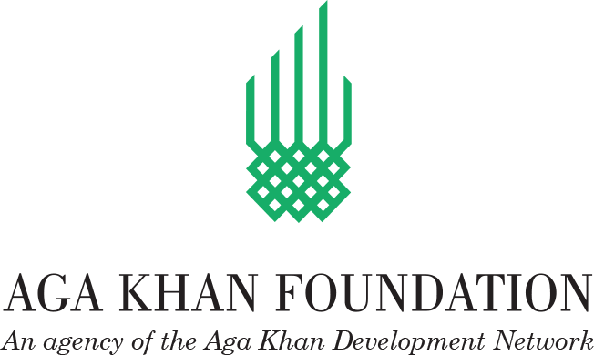

Notification of Intention to Award
Employer: AGA KHAN FOUNDATION-Afghanistan (AKF-A)
Project: Water Emergency Relief Project (WERP)
Contract title: Construction of Pipe Scheme with a Solar pump system IN Sayed village in Khulm Distirct and Ghaznigak village in Hazrat-e-Sultan District of Samangan Province.
Country: Afghanistan
Grant No.: P179311
RFQ No: Ref No: WB/WERP/AKF/SAM/KHU/HAZ/SAY/GHA/W175/176.
This Notification of Intention to Award (Notification) notifies you of our decision to award the above contract. The transmission of this Notification begins the Standstill Period. During the Standstill Period you may:
- request a debriefing in relation to the evaluation of your Bid, and/or
- submit a Procurement-related Complaint in relation to the decision to award the contract.
The successful Bidder
Name: | M/s Alaska Construction, Road Building and Engineering Company
Contract price: | USD 141,282.74.00 (One Hundred Fourty One Thousand Two Hundred Eighty-Nine point Eighty USD)
The Firms who want debriefing on any issue related to this procurement may request so in writing within 5 working days from the date of issue of this award Notice to Procurement department, AGA KHAN FOUNDATION-Afghanistan (AKF-A). Protest shall not be accepted beyond the deadline. Protest must be addressed in writing to Procurement Department of AGA KHAN FOUNDATION (AKF) located at Aga Khan Foundation-P.O.5753, House No. 1003, District No. 10- Madina Bazar, Beside Shahre Now Wedding Hall, Black Gate, Kabul, Afghanistan.
This notice doesn’t constitute a contract until the deadline for completion stipulated herein and completion of further processes.

