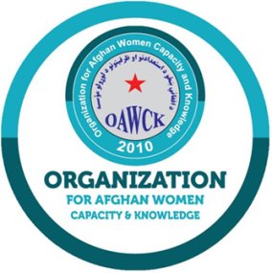

Organization for Afghan Women Capacity and Knowledge (OAWCK)

REQUEST FOR QUOTATION

For partial Repairing/Rehabilitating of 50 Existing Wells

In Mazar i Sharif District of Balkh Province.

Ref#: ERWSF&HP/22-04

Issue Date: 04/12/2022
Closing Date: 10/12/2022

CONTACT DETAILS

OAWCK Head Office - Kunar:
Name: | Admin & Logistic Department
Title: | Logistic Officer
Telephone: | +93774780045
E-mail: | Procurement@oawck.org.af
Address: | OAWCK main office next to Agriculture Directorate of Kunar, Mandakol road, Asadabad Kunar Province

Table of Contents
CONTACT DETAILS 1

1. About OAWCK 3

2. Description: 3

3. Scope of Work 3

4. Cost of Providing Offers: 3

5. Offer Documents: 3

5.1. Clarification of Solicitation Documents: 3

5.2. Amendments of Request for Quotation: 3

6. Preparation of Offers: 3

6.1. Language of the Offer: 3

6.2. Offer Currencies/Offer Prices: 4

6.3. Period of Validity of Offers: 4

7. Opening and Evaluation Criteria: 4

7.1. Cost-Effectiveness: 4

7.2. Bid Security 4

7.3. Relevant Experience: 4

7.4. Bank Statement: 4

7.5. Work plan and Project Manager: 4

8. Preliminary Examination: 5

9. Evaluation of Offer: 5

10. Evaluation and Basis for Award 5

11. Negotiations 5

12. Certifications and Compliance 5

13. Pertinent Information 6

14. Offer Documents. 6

Your offer package should include the following essential documents. 6

15. Project Duration and Penalty for Late Work: 7

16. Payment Terms: 7

17. Offer Submission Guidelines: (Open Bidding) 7

18. Returnable Bid Forms 7

19. Bidder information 10

- About OAWCK

Organization for Afghan Women Capacity and Knowledge (OAWCK) is an Afghan, independent, non-political, non-sectarian, non-profit organization established in Afghans in 2010 with a registration number of 1888 with the Ministry of Economy of the Islamic Republic of Afghanistan.

In humanitarian situations emerging as result of conflict or natural disasters, natural, the response encompasses the provision of tools and resources i.e., to reduces the suffering and increase self-sufficiency.

Our approach includes sustainable development, focusing on ultra-poor communities of Afghanistan. The endeavors focus on social and economic development of the people dwelling in remotes parts of the country.

Through peace building efforts, we envision Afghanistan a socially inclusive society where peace and prosperity remains a fate for every individual living in this territory. Promote the social cohesion, curtailing extremism in all forms, inclusiveness of peace processes where children, women and marginalized groups have a voice.

- Project Description:

OAWCK through this RFQ is requesting eligible bidder (firms and construction companies) for Repairing/Rehabilitating of 50 Existing Wells in different parts in Mazar i Sharif district of Balkh Province, project must be completed in 150 calendar days after the award of contract.

- Scope of Work

For scope of work and technical specifications please see the attached Annex-I. Bidders are required to sign and stamped the Annex-I and submit it along this RFQ document.

- Cost of Providing Offers:

The bidder shall bear all costs associated with the preparation and submission of bid in response to this solicitation/RFQ.

- Offer Documents:

5.1. Clarification of Solicitation Documents:

The bidder requiring any clarification on the Request for Quotation may notify OAWCK in a written form. The response will be made in writing to any request for clarification of the RFQ that received by the mentioned deadline for questions. Clarification may be sought in writing through authorized representative email: procurement@oawck.org.af for clarifications only no later than December 07, 2022, before 12:00 AM. For submittal of bids please see the instructions set forth.

5.2. Amendments of Request for Quotation:

Prior to the Deadline for Submission of Offers, OAWCK may, for any reason, whether at its own initiative or in response to a clarification requested by a prospective bidder, may amend this Request for Quotation. In order to afford prospective bidder reasonable time in which to take the amendments into account in preparing their offers, OAWCK may, at its discretion, extend the Deadline for the Submission of Offers. Any amendments will be published in the same manner as the present RFQ for which the bidders are required to keep an eye on the advertised RFQ till its deadline, for any amendment made there.

- Preparation of Offers:

6.1. Language of the Offer:

The Offer prepared by the bidder and all correspondence and documents relating to the Offer exchanged by the company and OAWCK shall be in English Language only.

6.2. Offer Currencies/Offer Prices:

Prices shall be offered in USD and OAWCK’s preferred payment term is only through bank form in a minimum of 30 days’ net. The bidder shall receive the amount only through a specified bank account and will be transferred in minimum of 30 days after the service delivery. Bidders may request a different payment term, though it remains an evaluation factor.

6.3. Period of Validity of Offers:

The Offer shall remain valid for 60 days after the closing date prescribed by OAWCK. An Offer valid for a shorter period may be rejected as non-responsive.

- Opening and Evaluation Criteria:

To assist in the examination, evaluation, and comparison of Offers, OAWCK may at its discretion ask the bidder for clarification of their Offers. The following criteria will be applied for the evaluation and scoring of bids.

7.1. Cost-Effectiveness:

OAWCK’s procurement department and the technical committee for evaluation of the offers shall have the right to take the decision on Cost-Effectiveness for the shortlisted bids as per and according to OAWCK, Donor and international standards allocated for the specified items with cost-effectiveness.

Although the Lowest cost is technically acceptable, the bids should meet at least the identified standards for items as per technical specification. (60 points).

7.2. Relevant Experience:

According to organization policy, bidders should have the capacity and experience of at least 2 contract implemented in past 5 years. Copies of the contracts should be part of the offer and will receive score. (15 points).

7.3. Bank Statement:

According to organization’s policy, bidders should have the financial capacity to conduct the work without hindrance. The required closing balance at the bank or FSP/MSP (Sarafi/Hawala) account in the supplier’s name is 40% of the total estimated cost of the company during RFQ announcement. (15 points).

7.4. Work plan and Project Manager:

Comprehensive Construction Work plan and Project Manager Civil Eng. with 3-5 Year work Experience (total 15 points 8 for work plan and 7 for PM).

8. Preliminary Examination:

Arithmetical errors will be rectified on the following basis: If there is a discrepancy between the unit price and the total price that is obtained by multiplying the unit price and quantity, the unit price shall prevail and the total price shall be corrected. If the Supplier/Vendor does not accept the correction of errors, its Offer will be rejected. If there is a discrepancy between words and figures, the amount in words will prevail.

An offer determined as not substantially responsive will be rejected by OAWCK and may not subsequently be made responsive by the bidder by correction of the non-conformity.

9. Evaluation of Offer:

Determination of compliance with the RFQ is based on the content of the Offer itself without recourse to extrinsic evidence.

- Evaluation and Basis for Award

A Contract will be executed with the Bidder whose quotation is determined to be responsive to this RFQ document, meets the eligibility criteria stated in this RFQ, meets the technical, management/personnel, and corporate capability requirements, and is determined to represent the best value to the organization.

That means that each quotation will be evaluated and scored against the evaluation criteria and evaluation sub-criteria, which are stated below.

  - Cost-Effectiveness

  - Relevant Experience

  - Bank Statement

  - Work plan and Project Manager

OAWCK reserves the right to reject any and all bids at its sole discretion for any reason whatsoever. The quantity requested in this RFQ does not create liability for OAWCK and that OAWCK may determine to reduce or increase the quantity cited in this RFQ at the order stage.

11. Negotiations

It is anticipated that a ‘Contract’ will be awarded solely on the basis of the original offers received. However, OAWCK reserves the right to negotiate the price and the terms and conditions offered by the bidder by requesting clarifications prior to award or proposing adjustments to the quotation. Furthermore, OAWCK reserves the right to conduct a competitive range and to limit the number of Bidders in the competitive range to permit an efficient evaluation environment among the most highly rated quotations. At the sole discretion of OAWCK, Bidders may be requested to conduct oral presentation.

12. Certifications and Compliance

Bidders shall be expected to comply with the following policies and regulations. The bidder must be registered as per the local law and hold a valid license. As per the Afghanistan government tax law, OAWCK withholds 2% tax from the total value contract where the supplier is registered with the government of Afghanistan, while the withholding tax rate for non-registered companies/individuals is 7%. OAWCK releases the tax to the account of MoF and provides confirmation to the respective bidder. This tax is a sole responsibility of OAWCK and therefore, it should be included in the final price that will be offered to OAWCK in response to this solicitation.

- Pertinent Information

  - The OAWCK shall have the right to reject the offer if it does not conform to the requirements of the RFQ.

  - The OAWCK reserves the right to waive any specification or condition stated in this request for quotation in the interest of operational needs or to ensure best value and suitability to organization.

  - Please be informed that the actual required work may differ (increase or decrease) depending on operational needs and hence the OAWCK should not be held responsible for any such changes.

  - Failure to comply with the OAWCK requirement will justify the rejection of your offer.

  - Within the contractual period any changes of the price will not be allowed and any approaches from the contractor requesting for a price increase or expertise unavailability will be considered as non-performance and thus the contract will be void.

  - If not clear in any specification, please communicate and confirm before submitting the offer.

- Offer Documents.
Your offer package should include the following essential documents.

  - Copy of this RFQ documents should be enveloped signed and stamped.

  - Returnable Bid Forms (include BoQs).

  - Work plan, CV and certificates of Project Manager

  - Legal business registration/certificates.

  - Copy of the bank statement where the name of the firm/company and the bank account is legible (certifying the bank account and owner of the bank account).

  - Past performance evidence (list of previous contracts, name and contact details of clients).

  - Bank account USD and AFN from Islamic Bank of Afghanistan.

In addition, your offer should be submitted with information as following.
- Your offer should be submitted through procurement@oawck.org.af

- Subject line of the email should be ‘Ref#: ERWSF&HP/22-04. Offers not addressed and sent as such will not be considered.
- Your offer should be clear and legible, (in the English language preferable)

- Your offer should state the offer issuing date.

- Your offer should be numbered.

- Your offer should be specific on the offer validity date.
  - Price should be offered in USD; however, the organization may consider currency change to AFN as per the procurement regulations.

  - Your offer should be duly signed and stamped.

  - Complete bank details, as all payments will be made only through bank transfer.

  - The bidder firm is responsible for all costs/expertise involved in preparing the offer, and OAWCK bears no responsibilities to reimburse the costs spent on preparation of the offer either the firm is qualified or disqualified.

- Project Duration and Penalty for Late Work:

The projected duration is 5 months (150 calendar days) after award of contract; the procurement penalty of 0.05% will be applied per working day after project end date (150 calendar days).

16. Payment Terms:
Payment will be made in three installments,

- First installment 40% after 50% physical completion of the project and verified by OAWCK Balkh province assigned team.

- Second installment 80% after 90% physical completion of the project and verified by OAWCK Balkh province assigned team.

- 3rd installment 100% payment after the completion and final handover of the project, as certified by OAWCK and relevant stakeholders.

Payment will be made to the contractor within the 30 days once invoice is received and work is attested by the OAWCK Balkh staff, considering the banking regulations i.e. no liabilities will be incurred to OAWCK if banking system restricts the payments due to unforeseen circumstances and the 30 days’ period exceeds. The payment is subjected to tax as per Afghan Tax Law, which will be deducted from payment to the contractor.

17. Offer Submission Guidelines:

Bidders shall submit the offers via email procurement@oawck.org.af with RFQ number in the subject line.

18. Returnable Bid Forms

This BoQ contains statements required in the Offer documents and shall be signed by a duly authorized person. Any addition to, deletion or alteration in the BoQ may result in rejection of the Offer.

Please prior to quoting your prices conduct a site survey. The quantities mentioned in the BoQ may vary with actual work on site. OAWCK will carry out a re-estimation of the actual work done against the work mentioned in the BoQ. For any extra work OAWCK shall be contacted on prior basis and approval shall be sought for extra Work. Any extra work done without the approval/permission of OAWCK shall be considered void and no payment will be disbursed for the work done.

Partial Repairing of Well
S/N | Description | Unit | Quantity | Unit Cost/$ | Total Cost/$
1 | Pamir Hand-pump: Provide and installation of Pamir hand-pump, Kawsar or equivalent based on the Pamir hand-pump standard specifications. Complete set (Pedestal, Handle, Cylinder and other accessories) | Set | 1
2 | Concrete Apron: Construction of well apron according to the designed drawing and specifications, Include curing. | L/S | 1
3 | Raising Pipe: Preparation and installation (lowering) of 2 inch (BSR Royal, PVC pressure pipe class-E), (according to Royal company specifications. Include all necessary accessories. | M | 50
4 | Raising rod: Preparation and installation (lowering) of rods (2.9 meter, 10 mm galvanized steel rod) based on the company specifications. | Rod | 18
5 | Washer: Provide and installation of 19 raisin rod washers, based on the company specifications. | No | 19
6 | Glue: Provide and applying standard glue (adhesives) | KG | 1
7 | Paint: Provide and apply oil paint around the concrete apron. | L/S | 1
8 | Plastic rope: Provide and install 10mm plastic rope for hand pump. | M | 110
9 | Site Cleaning. | L/S | 1
TOTAL/USD
BoQ for partial Repairing/Rehabilitating of 50 Existing Wells in different parts of Mazar i Sharif district of Balkh Province

Summary sheet for partial Repairing/Rehabilitating of 50 Existing Wells in different parts of Mazar i Sharif district of Balkh Province

Code# | Description | Unit | Qty | Unite Price $ | Total price including 2% tax$
1 | Partial Repairing/Rehabilitating of 50 Existing Wells in different parts in Mazar i Sharif district of Balkh Province. | Each | 50

Essential Note for BoQs

- Building materials/Construction material and Works may be subject to tests at any time at the request of OAWCK technical team/Engineer. These tests shall be carried out as directed by the Engineer or Authorized Repetitive at the place of Manufacture or fabrication or on site or in testing institute. The Contractor shall provide such assistance materials, plant, instruments and labor as required for such test. The cost of carrying out such tests shall be borne by the contractor.

- The works actually executed shall be measured and is subject to deduction, Contractor shall visit the site of the works and obtain all information that may be necessary for completing their Offer as under the provision of this contract no claim for additional work is accepted once contract is signed.

- If, in the Contractor opinion, The BoQ contains ambiguities or BoQ does not comply with the drawings which might influence the calculations, the contractor shall indicate this to OAWCK through a letter or email before submitting the Offer.

- Mobilization, Demobilization and other temporary works required for the execution of the items listed above, plus site restoration will be the responsibility of the contractor. Hence all the unit prices are assumed to cover all activities associated with the works, and are not limited to those activities mentioned above, and that the total contract cost quoted is all inclusive to complete the total works.

17. Bidder information

Persons authorized to sign bids, offers and contracts
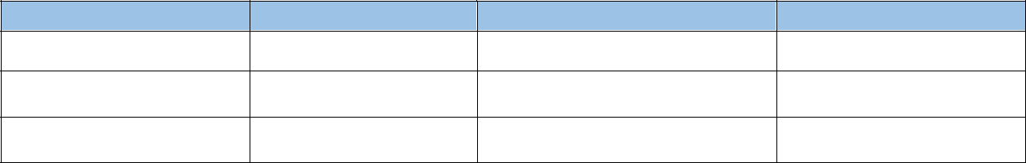

Name

Title

Email

Telephone

Banking Information:

Payment shall be made only through bidder’s specified bank account, please provide your banking information as requested below. Considering the banking restrictions, no other than FMFB bank account in the supplier’s name is the OAWCK able to make payment to the supplier. This in good faith the supplier is required to comply with, failure to meet with this specific requirement will justify the rejection of your offer by OAWCK, however, if currently holding no account at Islamic Bank of Afghanistan the bidder may commit to open the account in case of contract award.

Bank Name: _________________________________________________(Essentially IBA)___

Account Name: _________________________________________________________________

Account Number: ____________________________ SWIFT Code: ________________________

Sign and Stamp of the Bidder Firm

Annex-I

SCOPE OF WORKS

Technical specification for partial repairing/rehabilitation of 50 existing well

In Chemtal district of Balkh province.

Partial Repairing/Rehabilitating of 50 Existing Wells in different parts in
Mazar i Sharif of Balkh Province
“Negotiating procedure

  - PURPOSE OF THIS “TENDERING DOCUMENT:

This tendering document concerns the project Organization for Afghan Women Capacity and Knowledge (OAWCK) is planning to implement through the funding and collaboration of UN-OCHA to partial Repairing/Rehabilitating of 50 Existing Wells in different parts in Mazar i Sharif District of Balkh Province.

  - DESCRIPTION OF THE ACTIVITIES

This is a succinct description of the activities to do. The technical specification required will be described below. The designs are in Appendix.
- Partial Repairing/Rehabilitating of each well in different parts of two districts shown in BoQ
- The delivered task should be completed within five months of award of contract.

  - LOCATION AND ACCESSIBILITY:

The partial Repairing/Rehabilitating of 50 Existing Wells in different parts of Mazar i Sharif district in Balkh Province. OAWCK team in collaboration with the districts of Balkh province water/ WASH committee, Local government and community elder will mark the exact locations of each well site. OAWCK will hand over the site to successful contractor to initiate the agreed repairing and civil works through a joint OAWCK and community visits.

- RESPONSIBILITY OF THE CONTRACTOR:

The contractor will have to start his activities, deploy his machinery, tools, material, site staff, and equipment in the Mazar i Sharif district As per the agreed implementation plan and are aware of the accessibility constraints.

  - The work contractor shall fill the 2 following documents which are to complete the parts of this file: Work Contractor's Declaration Including the Financial Identification and AISA Registration documents

  - Besides, he will provide an additional and official pro forma and the technical specifications of all the items proposed.

- The purchase of all the materials would be submitted to a work contract (approvals), under authority of OAWCK.

- The type of contract will be paid in real expenses and the quotation amount has to be presented in USD.

- The Contractor should be ready to start the works as agreed with OAWCK after the notification of call for negotiated procedure results.

- It is up to the Contractor to arrange at his own expenses the necessary for mobilization of required staff and stock of materials installation on site for the defined work.

- The contractor will manage with his own means the supply of adequate and necessary materials, equipment and labor to the working site.

- The Contractor will have to strictly follow the National guidelines of MRRD in term of Water Supply Technology/Technical options (Annex ) as well as the technical requests and recommendations of OAWCK mentioned

- A good coordination between OAWCK and the contractor will have to be done through regular field visit and coordination meeting being arranged by the Logistics department of OAWCK.

- The work has to be realized in good co-operation with the mention village Water/ WASH Committees and PRRD and Municipality representatives for these targeted sites, which will be responsible of the Operation and Maintenance of the water sources (boreholes and water points) of the project after hand-over by OAWCK. The WASH Committees are hereby authorized to monitor the works of the contractor and report to OAWCK WASH staff for any dissatisfaction of works or materials being used at site.

- The contractor will have to respect a strict agreed execution of the planed works.

- Security on the field is under the contractor responsibility; however, the contractor will benefit from OAWCK network information. In case insecurity events occurred, a temporary suspension could be considered with prior authorization from OAWCK representative.

- It is also under Contractor responsibility to ensure a safety barrier around the site and to prevent any incident with the civilians/ villagers.

- The Contractor will be responsible for the security of his equipment and staff on the site and OAWCK will not be at any case responsible of any degradation or stealing of material and equipment or harm to contractor staff. It is up to the Contractor to ensure the security maybe by relying on guards.

- If it appears in the middle of the work, that the Contractor cannot fulfill his obligation in time, he will have to reinforce his means in order to complete the work within the completion period.

- The Contractor will be fully responsible for cleaning and removing all materials/ waste materials and equipment after the completion of the works. A clean place will have to be set up as it belongs to the governmental area.

- A visit of conformity for the materials will be carried out by OAWCK staff at the beginning of works, with an aim of notifying:

o Conformity with the material proposed in the offer,

o Compatibility between the capacities of this material, technical specification of this document and completion periods.

- The pronunciation of this conformity per official report does not relieve in any case the Assignee of his engagements.

- The Contractor is held to attend all the appointments of working site fixed by OAWCK. He will make sure that an agent whom will have all due capacities and power for the building site management will represent him.

- All the material that the contractor will use for the work will be subject to the approval of OAWCK responsible staff or its representative.

- All the debris materials will have to be evacuated by the Contractor at his own expenses.

  - The contractor is responsible for a regular supply of material to ensure the smooth work of the site in order to fulfill his commitments.

  - Notwithstanding the approval of OAWCK for the quality of materials, the Contractor remains responsible for quality for the used materials.

  - It is from his responsibility to carry out and at his own expenses, all the material analyses and all necessary tests to a good execution of the works.

  - The Contractor is in charge to follow all the steps, for obtaining all authorizations or agreements and for paying for all the expenses, royalties or allowances resulting from the influence of the installation in targeted sites.

  - The importation of materials and supplies will be subjected to the preliminary authorization of OAWCK on justification that equivalent materials or supplies cannot be found in Afghanistan. Any change in the origin of materials and supplies imported must be authorized beforehand by OAWCK.

  - OAWCK will pay if the borehole is declared positive (definition in technical specifications). OAWCK will not pay any amount of money if the borehole is declared negative.

  - A penalty of 0.05% from total amount of contract per day of delay in the completion of the work will be applied

- TECHNICAL SPECIFICATION AND DESIGN

A – MATERIALS & TECHNICAL SPECIFICATION Concrete Works:
Cement:
  - Standard quality fresh Portland cement shall be used for all concrete work and other cement related activities, bags weight should be 50kgs, rather than any other packaging.

  - Recoveries of cement dust will be prohibited.

  - Cement use on the site should not be stored over long periods (more than two months); the Engineer on site will check the quality on regular basis, it should meet all storing rules.

  - Concrete work shall be carried out from concrete past having strength of M:200.

  - Compressive strength of Mortar for pointing work should be M:250.

Sand:
- Sand calibration: 1-3mm.

- The sand should be from a river basin or sand borrows, it should be free of lumps and dust.

- The sand used to prepare the mortar must be washed to avoid any soil particles being available.

Gravel:
The gravel used for the civil works (concrete) must be crashed, cleaned and have a 1 to 3 Cm diameter.

Water:
The water used for every construction work needs to be completely clear (turbidity should not be more than 5 NTU).

Gravel pack:
The gravel to use as filtering layer must have a size between 5mm and 15 mm. It should be from a river basin, artificial gravel will not be accepted, and it should be washed and clean.

Clay:
The clay must be industrial quality and delivered in small aggregates, if possible. If not available, the clay used to create the plug should come in chunks of small size (less than 5 cm) to avoid them to be stuck in a higher position than supposed to.

Hand Pumps and fetching equipment:

Hand Pump (Pamir)
The hand pump to install must be of the model Pamir type. The hand pump parts should be in compliance to drawing and specification of MRRD/SKAT. The parts (Steel Plates, sheets, Angle iron leg and square bars for fabrication) should also confirm to Pamir Hand Pumps confirm and OAWCK technical team will validate the quality of the hand pumps.

Shallow well or bore hole:

- Definition of a positive well:
  - Has a minimum of 20m of water column in bore hole.
  - Has a minimum of 1.5 of water column in shallow well.

  - Gives clean water after reparation.

  - Is equipped according the MRRD regulations

- Procedure of equipment:
- Pamir Hand-pump: Provide and installation of Pamir hand-pump, Kawsar or equivalent based on the Pamir hand-pump standard specifications. Complete set (Pedestal, Handle, Cylinder and other accessories).
- Concrete Apron: Construction of well apron according to the designed drawing and specifications, Include curing.
- Raising Pipe: Preparation and installation (lowering) of 2 inch (BSR Royal, PVC pressure pipe class E), (50 meters) according to company specifications, include all necessary accessories.
- Raising rod: Preparation and installation (lowering) of 18 rods (2.9-meter, 10 mm galvanized steel rod) based on the company specifications.
- Washer: Provide and installation of 19 raising rod washers, based on the company specifications.
- Glue: Provide and applying standard glue (adhesives)
- Paint: Provide and apply oil paint around the concrete apron.
- Plastic rope: Provide and install 110m, 10mm plastic rope for hand pump.
- Site Cleaning.

3. Development

  - The development will be continued until obtaining perfectly clear water, without sandy or argillaceous particles. The water level and the depth of the work will be measured before and after development.

  - There should one development before installation of the casing for a minimum length of 4 h.

  - There should be a second development after the installation of the casing for a minimum length of 4 h.

  - The minimum yield during the development should be 0.2 L/s.

  - One generator and submersible pump must be available for the pump test.

4. Apron Construction

The apron must be constructed according to MRRD regulations and design:
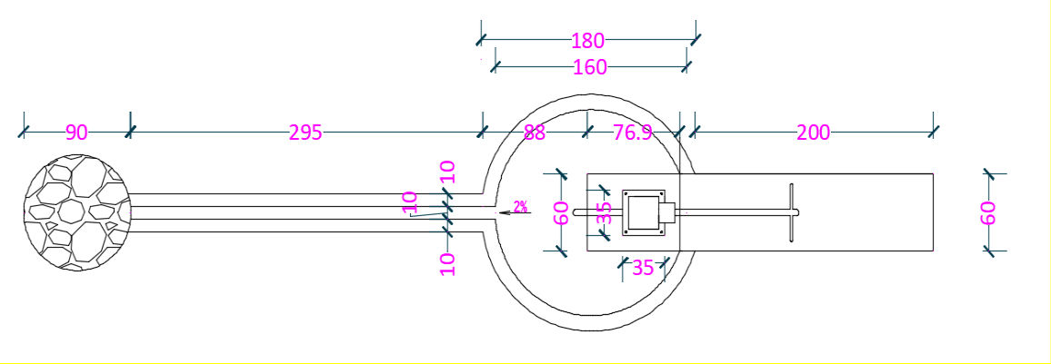

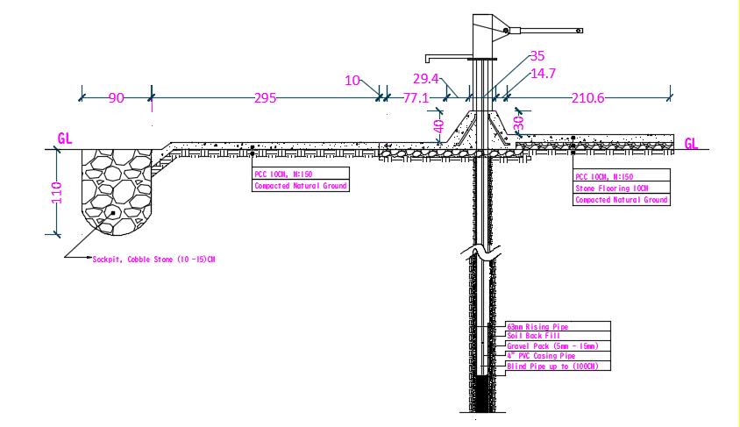

5. Hand Pump Installation

In order to install the hand pump, the contractor needs to get authorization from the OAWCK team. The installation of the hand pump and its pipes must be completed according to standard MRRD/SKAT regulations.

6. Site Clearing

After each completion of the work, the contractor must remove all remaining sand, gravels, and cuttings from the site. He must also remove all rubbish left over from the workers and remove the drilling machines.

7. Work Follow-Up

In order to allow an effective follow-up of work, the Contractor will hold a Journal for site on which all information related to the work will be reported. This book will allow the OAWCK controller, as of his arrival on the site, to know exactly the progress report of drilling work. The remarks and reserves of the Contractor and/or the person in charge for the program will be notified in Journal. A copy of Journal has to be given to OAWCK in the end of the project and might be use as intermediate or final report to the donor. On Journal, all information will be written down concerning:

  - Name of the building site (number of the Wells with description of the location);

  - For each reparation , date and hour of arrival, starting and finishing of the rehabilitation ;

  - Everyday Hour of installation and hour of beginning of drilling;

  - Diameter and technique used meter per meter;

    - Duration, yield, the limpidity of water and various water levels at the time of the operations of development and flow;

    - Generally, all technical details, incidental, clean breakdowns, difficulties with the course of work, with indication of the hours when they occurred.

- Work Plan

The Contactor should submit actual project implementation work plan in P6 or Excel format, the project must be finished within 5 months after award of contract.

Table: 2, Construction and Rehabilitation Plan:

The project work should be carried out within 5 months, no later than, if he could accomplish prior then five months this would vendors’ efficiency.

No | Activity  Description | 1st Month |  |  |  | 2nd Month |  |  |  | 3rd Month |  |  |  | 4th Month |  |  |  | 5th Month
1 | Staff, Machinery and mobilization.
2 | Construction of Apron according to drawing and specification.
3 | Provide & Installation of Hand pump with all accessories.
4 | Painting of Apron
5 | Site cleaning
6 | Project closing and hand overing

